Practical 1
1] Programming Resources Android Resources: (Color, Theme, String, Drawable, Dimension, Image) activity_main.xml
<?xml version="1.0" encoding="utf-8"?>
<LinearLayout xmlns:android="http://schemas.android.com/apk/res/android" android:layout_width="match_parent" android:layout_height="match_parent"
android:gravity="center" android:orientation="vertical" android:padding="@dimen/padding_standard">

<ImageView android:id="@+id/myImage" android:layout_width="150dp" android:layout_height="150dp" android:src="@drawable/cats" />

<TextView android:id="@+id/myText"
android:layout_width="wrap_content" android:layout_height="wrap_content" android:text="@string/hello_text" android:textColor="@color/myTextColor" android:textSize="@dimen/text_size_large" android:background="@drawable/rounded_box" android:padding="@dimen/padding_standard"/>
</LinearLayout>

colors.xml
<resources>
<color name="colorPrimary">#6200EE</color>
<color name="colorPrimaryDark">#3700B3</color>
<color name="colorAccent">#03DAC5</color>
<color name="myTextColor">#FF5722</color>
</resources>

strings.xml
<resources>
<color name="colorPrimary">#6200EE</color>
<color name="colorPrimaryDark">#3700B3</color>
<color name="colorAccent">#03DAC5</color>
<color name="myTextColor">#FF5722</color>
</resources>

dimens.xml
<resources>
<color name="colorPrimary">#6200EE</color>
<color name="colorPrimaryDark">#3700B3</color>
<color name="colorAccent">#03DAC5</color>
<color name="myTextColor">#FF5722</color>
</resources>

themes.xml
<resources>
<color name="colorPrimary">#6200EE</color>
<color name="colorPrimaryDark">#3700B3</color>
<color name="colorAccent">#03DAC5</color>
<color name="myTextColor">#FF5722</color>
</resources>

rounded_box.xml
<resources>
<color name="colorPrimary">#6200EE</color>
<color name="colorPrimaryDark">#3700B3</color>
<color name="colorAccent">#03DAC5</color>
<color name="myTextColor">#FF5722</color>
</resources>

MainActivity.java
package com.example.pract1;

import androidx.appcompat.app.AppCompatActivity; import android.os.Bundle;
import android.widget.ImageView; import android.widget.TextView;

public class MainActivity extends AppCompatActivity { @Override
protected void onCreate(Bundle savedInstanceState) { super.onCreate(savedInstanceState); setTheme(R.style.Theme_ResourceDemo); setContentView(R.layout.activity_main); TextView textView = findViewById(R.id.myText);
ImageView imageView = findViewById(R.id.myImage); textView.setText(getString(R.string.hello_text)); textView.setTextColor(getColor(R.color.myTextColor)); imageView.setImageResource(R.drawable.cats);
}
}
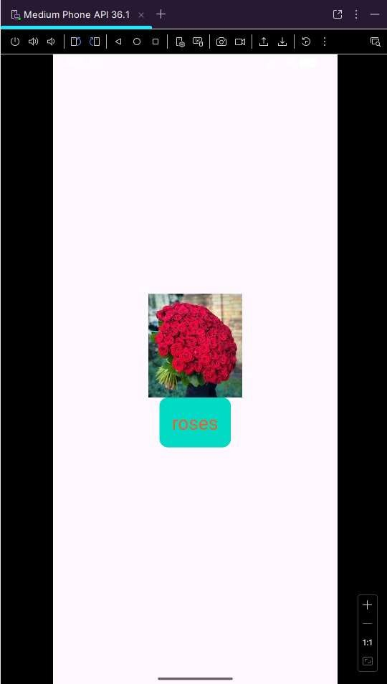
Output:

Practical 2

- The Life cycle methods of Android Activity MainActivity.java:
package com.example.practical2;

import android.os.Bundle; import android.util.Log;
import androidx.appcompat.app.AppCompatActivity;

public class MainActivity extends AppCompatActivity { String TAG = "ActivityLifeCycle";
@Override
protected void onCreate(Bundle savedInstanceState) { super.onCreate(savedInstanceState); setContentView(R.layout.activity_main); Log.d(TAG, "onCreate called");
}
@Override
protected void onStart() { super.onStart();
Log.d(TAG, "onStart called");
}
@Override
protected void onResume() { super.onResume();
Log.d(TAG, "onResume called");
}
@Override
protected void onPause() { super.onPause();
Log.d(TAG, "onPause called");
}
@Override
protected void onStop() { super.onStop();
Log.d(TAG, "onStop called");
}
@Override
protected void onRestart() { super.onRestart();
Log.d(TAG, "onRestart called");
}
@Override
protected void onDestroy() { super.onDestroy();
Log.d(TAG, "onDestroy called");
}
}

Activity_main.xml
<?xml version="1.0" encoding="utf-8"?>
<LinearLayout xmlns:android="http://schemas.android.com/apk/res/android" android:layout_width="match_parent" android:layout_height="match_parent"
android:gravity="center" android:orientation="vertical">

<TextView android:layout_width="wrap_content" android:layout_height="wrap_content" android:text="Activity Life Cycle Demo" android:textSize="20sp" />
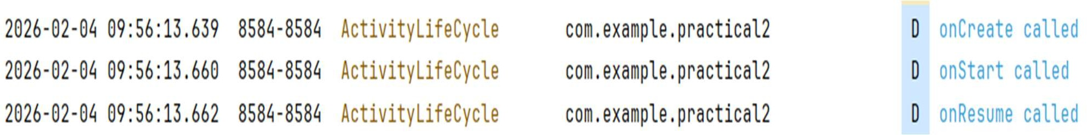
</LinearLayout> Output:

Lifecycle of fragments and multiple fragments MainActivity.java
package com.example.practical2; import android.os.Bundle; import android.util.Log;
import android.widget.Button;
import androidx.appcompat.app.AppCompatActivity; import androidx.fragment.app.FragmentManager; import androidx.fragment.app.FragmentTransaction;

public class MainActivity extends AppCompatActivity { String TAG = "MainActivity";
@Override
protected void onCreate(Bundle savedInstanceState) { super.onCreate(savedInstanceState); setContentView(R.layout.activity_main); Log.d(TAG, "onCreate");
Button btnLoadFragment = findViewById(R.id.btnLoadFragment); btnLoadFragment.setOnClickListener(v -> {
Log.d(TAG, "Button clicked - loading Fragment"); Fragment1 fragment = new Fragment1(); FragmentManager fm = getSupportFragmentManager(); FragmentTransaction ft = fm.beginTransaction(); ft.replace(R.id.fragmentContainer, fragment); ft.commit();
});
}
@Override protected void onStart() { super.onStart();
Log.d(TAG, "onStart");
}
@Override protected void onResume() { super.onResume();
Log.d(TAG, "onResume");
}
@Override protected void onPause() { super.onPause();
Log.d(TAG, "onPause");
}
@Override protected void onStop() { super.onStop();
Log.d(TAG, "onStop");
}
@Override protected void onDestroy() { super.onDestroy();
Log.d(TAG, "onDestroy");
}
}

Fragment1.java
package com.example.practical2; import android.os.Bundle; import android.util.Log;
import android.view.LayoutInflater; import android.view.View;
import android.view.ViewGroup; import androidx.annotation.NonNull; import androidx.annotation.Nullable;
import androidx.fragment.app.Fragment;

public class Fragment1 extends Fragment { String TAG = "Fragment1";
@Override
public void onCreate(@Nullable Bundle savedInstanceState) { super.onCreate(savedInstanceState);
Log.d(TAG, "onCreate");
}
@Nullable @Override
public View onCreateView( @NonNull LayoutInflater inflater, @Nullable ViewGroup container,
@Nullable Bundle savedInstanceState) { Log.d(TAG, "onCreateView");
return inflater.inflate(R.layout.fragment_1, container, false);
}
@Override
public void onStart() { super.onStart(); Log.d(TAG, "onStart");
}
@Override
public void onResume() { super.onResume(); Log.d(TAG, "onResume");
}
@Override
public void onPause() { super.onPause(); Log.d(TAG, "onPause");
}
@Override
public void onStop() { super.onStop(); Log.d(TAG, "onStop");
}
@Override
public void onDestroyView() { super.onDestroyView(); Log.d(TAG, "onDestroyView");

}
@Override
public void onDestroy() { super.onDestroy(); Log.d(TAG, "onDestroy");
}
}

Activity_main.xml
<?xml version="1.0" encoding="utf-8"?>
<LinearLayout xmlns:android="http://schemas.android.com/apk/res/android" android:layout_width="match_parent" android:layout_height="match_parent"
android:orientation="vertical" android:padding="16dp">
<Button
android:id="@+id/btnLoadFragment" android:layout_width="match_parent" android:layout_height="wrap_content" android:text="Load Fragment" />
<FrameLayout android:id="@+id/fragmentContainer" android:layout_width="match_parent" android:layout_height="match_parent" android:layout_marginTop="16dp" />
</LinearLayout>

Fragment_1.xml
<?xml version="1.0" encoding="utf-8"?>
<LinearLayout xmlns:android="http://schemas.android.com/apk/res/android" android:layout_width="match_parent" android:layout_height="match_parent"
android:gravity="center" android:orientation="vertical">
<TextView android:layout_width="wrap_content" android:layout_height="wrap_content" android:text="This is Fragment 1" android:textSize="20sp" />
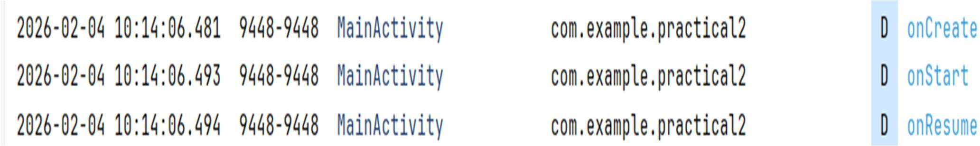
</LinearLayout> Output:

Practical 3
3] Programs related to different Layouts Coordinate, Linear, Relative, Table, Absolute, Frame, List View,View.

Relative Layout activity_main.xml
<?xml version="1.0" encoding="utf-8"?>
<RelativeLayout xmlns:android="http://schemas.android.com/apk/res/android" xmlns:app="http://schemas.android.com/apk/res-auto" xmlns:tools="http://schemas.android.com/tools" android:id="@+id/main" android:layout_height="match_parent" android:layout_width="match_parent" tools:context=".MainActivity">
<TextView android:id="@+id/lblComments" android:layout_width="wrap_content" android:layout_height="wrap_content" android:text="Comments" android:layout_alignParentTop="true" android:layout_alignParentLeft="true"/>

<EditText android:id="@+id/txtComments" android:layout_width="fill_parent" android:layout_height="69dp"
android:layout_below="@id/lblComments" android:layout_alignLeft="@id/lblComments" android:layout_centerHorizontal="true" android:layout_marginTop="-4dp" android:ems="10"
android:inputType="text" android:text="Name" android:textSize="18sp" />

<Button
android:id="@+id/btnShow" android:layout_width="300px" android:layout_height="wrap_content" android:text="Show" android:onClick="show" android:layout_below="@id/txtComments"
android:layout_alignLeft="@id/txtComments"
/>

<Button
android:id="@+id/btnClear" android:layout_width="300px" android:layout_height="wrap_content" android:text="Clear" android:onClick="clear" android:layout_below="@id/txtComments"

android:layout_alignRight="@id/txtComments"
/>
</RelativeLayout>

MainActivity.java
package com.example.relativelayout;

import android.os.Bundle;
import androidx.activity.EdgeToEdge;
import androidx.appcompat.app.AppCompatActivity; import androidx.core.graphics.Insets;
import androidx.core.view.ViewCompat;
import androidx.core.view.WindowInsetsCompat; import android.view.View;
import android.widget.EditText; import android.widget.Toast;
public class MainActivity extends AppCompatActivity { @Override
protected void onCreate(Bundle savedInstanceState) { super.onCreate(savedInstanceState); setContentView(R.layout.activity_main);
}
public void show(View v)
{
EditText d=findViewById(R.id.txtComments); String str = d.getText().toString();
Toast.makeText(this,str,Toast.LENGTH_SHORT).show();
}
public void clear(View v)
{
EditText d=findViewById(R.id.txtComments); d.setText("");
Toast.makeText(this,"Text Clear",Toast.LENGTH_SHORT).show();
}
}
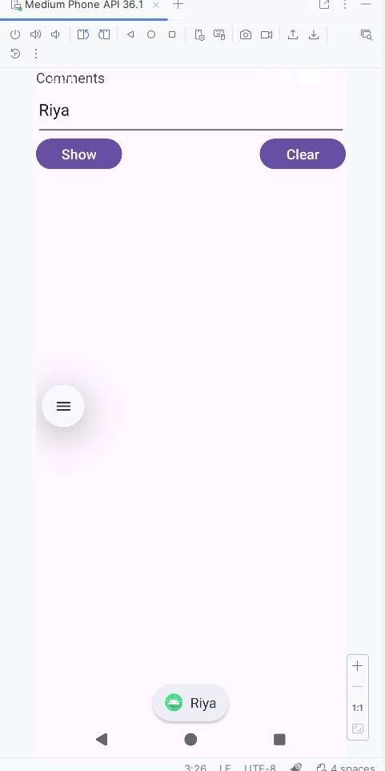
Output:

Linear Layout- vertical linear layout

activity_main.xml

<?xml version="1.0" encoding="utf-8"?>
<LinearLayout xmlns:android="http://schemas.android.com/apk/res/android" android:layout_width="match_parent" android:layout_height="match_parent"
android:orientation="vertical" android:padding="20dp">
<TextView android:layout_width="wrap_content" android:layout_height="wrap_content" android:text="Login Form" android:textSize="22sp" android:textStyle="bold" />
<EditText android:layout_width="match_parent" android:layout_height="wrap_content" android:hint="Username" />
<EditText android:layout_width="match_parent" android:layout_height="wrap_content" android:hint="Password" android:inputType="textPassword" />
<Button
android:layout_width="match_parent" android:layout_height="wrap_content" android:text="Login" />
</LinearLayout>

MainActivity.java
package com.example.linearlayout; import android.os.Bundle;
import androidx.appcompat.app.AppCompatActivity; public class MainActivity extends AppCompatActivity {
@Override
protected void onCreate(Bundle savedInstanceState) { super.onCreate(savedInstanceState); setContentView(R.layout.activity_main);
}
}

Output:
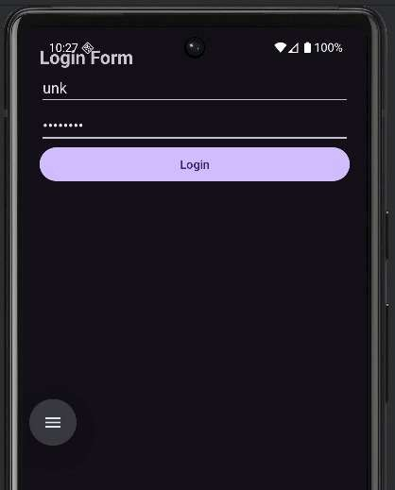

Horizontal linear layout activity_main.xml
<?xml version="1.0" encoding="utf-8"?>
<LinearLayout xmlns:android="http://schemas.android.com/apk/res/android" android:layout_width="match_parent" android:layout_height="match_parent"
android:orientation="horizontal" android:padding="16dp">
<Button
android:layout_width="wrap_content" android:layout_height="wrap_content" android:text="Button 1" />
<Button
android:layout_width="wrap_content" android:layout_height="wrap_content" android:text="Button 2" />
<Button
android:layout_width="wrap_content" android:layout_height="wrap_content" android:text="Button 3" />
</LinearLayout>

MainActivity.java
package com.example.horizontallinearlayout;

import android.os.Bundle;
import androidx.appcompat.app.AppCompatActivity; public class MainActivity extends AppCompatActivity {
@Override
protected void onCreate(Bundle savedInstanceState) { super.onCreate(savedInstanceState); setContentView(R.layout.activity_main);
}
}

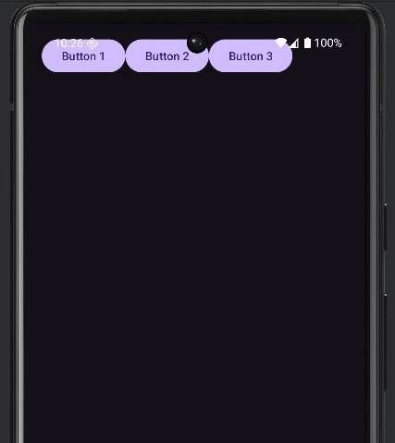
Output:

TableLayout
activity_main.xml
<?xml version="1.0" encoding="utf-8"?>
<TableLayout xmlns:android="http://schemas.android.com/apk/res/android" android:layout_width="match_parent" android:layout_height="match_parent"
android:padding="16dp" android:stretchColumns="1">
<TableRow>
<TextView android:text="Username" android:padding="8dp" />
<EditText android:hint="Enter username" />
</TableRow>
<TableRow>
<TextView android:text="Password" android:padding="8dp" />
<EditText android:hint="Enter password" android:inputType="textPassword" />
</TableRow>
<TableRow>
<TextView />
<Button android:text="Login" />
</TableRow>
</TableLayout>

MainActivity.java
package com.example.table; import android.os.Bundle;
import androidx.appcompat.app.AppCompatActivity; public class MainActivity extends AppCompatActivity {
@Override
protected void onCreate(Bundle savedInstanceState) { super.onCreate(savedInstanceState); setContentView(R.layout.activity_main);
}
}

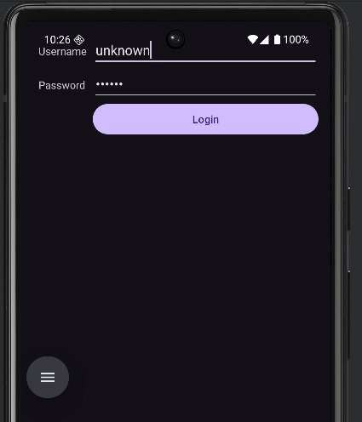
Output:

Scroll Layout activity_main.xml
<?xml version="1.0" encoding="utf-8"?>
<ScrollView xmlns:android="http://schemas.android.com/apk/res/android" android:layout_width="match_parent" android:layout_height="match_parent">

<!-- ScrollView can have ONLY ONE child -->
<LinearLayout android:layout_width="match_parent" android:layout_height="wrap_content" android:orientation="vertical" android:padding="16dp">

<TextView android:layout_width="wrap_content" android:layout_height="wrap_content" android:text="ScrollView Example" android:textSize="20sp" android:textStyle="bold" />

<EditText android:layout_width="match_parent" android:layout_height="wrap_content" android:hint="Field 1" />

<EditText android:layout_width="match_parent" android:layout_height="wrap_content" android:hint="Field 2" />

<EditText android:layout_width="match_parent" android:layout_height="wrap_content" android:hint="Field 3" />

<EditText android:layout_width="match_parent" android:layout_height="wrap_content" android:hint="Field 4" />

<EditText android:layout_width="match_parent" android:layout_height="wrap_content" android:hint="Field 5" />

<Button
android:layout_width="match_parent" android:layout_height="wrap_content" android:text="Submit" />

</LinearLayout>

</ScrollView>

MainActivity.java
package com.example.scroll;

import android.os.Bundle;
import androidx.appcompat.app.AppCompatActivity; public class MainActivity extends AppCompatActivity {
@Override
protected void onCreate(Bundle savedInstanceState) { super.onCreate(savedInstanceState); setContentView(R.layout.activity_main);
}
}

Output:
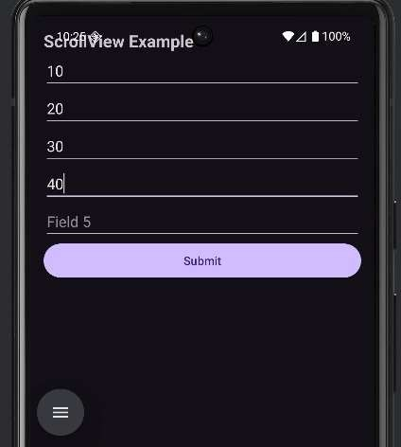

AbsoluteLayout activity_main.xml
<?xml version="1.0" encoding="utf-8"?>
<AbsoluteLayout xmlns:android="http://schemas.android.com/apk/res/android" android:layout_width="match_parent" android:layout_height="match_parent">
<TextView android:layout_width="wrap_content" android:layout_height="wrap_content" android:text="Absolute Layout" android:layout_x="50dp" android:layout_y="30dp" android:textSize="20sp" />
<Button
android:layout_width="wrap_content" android:layout_height="wrap_content" android:text="Button 1" android:layout_x="50dp" android:layout_y="100dp" />
<Button
android:layout_width="wrap_content" android:layout_height="wrap_content" android:text="Button 2" android:layout_x="180dp" android:layout_y="100dp" />
</AbsoluteLayout>

MainActivity.java
package com.example.absolute; import android.os.Bundle;
import androidx.appcompat.app.AppCompatActivity; public class MainActivity extends AppCompatActivity {
@Override
protected void onCreate(Bundle savedInstanceState) { super.onCreate(savedInstanceState); setContentView(R.layout.activity_main);
}
}
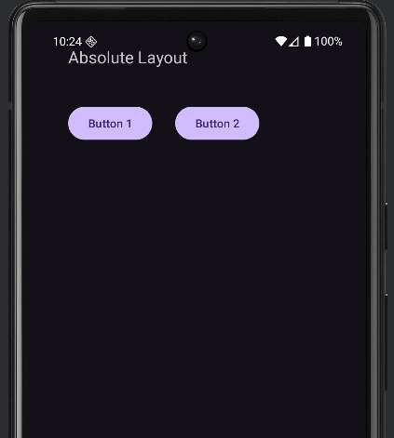
Output:

ListView

activity_main.xml

<?xml version="1.0" encoding="utf-8"?>
<LinearLayout xmlns:android="http://schemas.android.com/apk/res/android" android:layout_width="match_parent" android:layout_height="match_parent"
android:orientation="vertical" android:padding="16dp">

<TextView
android:layout_width="wrap_content" android:layout_height="wrap_content" android:text="ListView Example" android:textSize="20sp" android:textStyle="bold" />

<ListView
android:id="@+id/listView" android:layout_width="match_parent" android:layout_height="wrap_content" />
</LinearLayout>

MainActivity.java
package com.example.listview;

import android.os.Bundle;
import android.widget.ArrayAdapter; import android.widget.ListView;
import androidx.appcompat.app.AppCompatActivity;

public class MainActivity extends AppCompatActivity { ListView listView;
@Override
protected void onCreate(Bundle savedInstanceState) { super.onCreate(savedInstanceState); setContentView(R.layout.activity_main); listView = findViewById(R.id.listView);
String[] items = { "Android", "Java",
"Python",
"C",
"C++",
"Kotlin"
};
ArrayAdapter<String> adapter =
new ArrayAdapter<>(this, android.R.layout.simple_list_item_1, items);

listView.setAdapter(adapter);
}
}

Output:
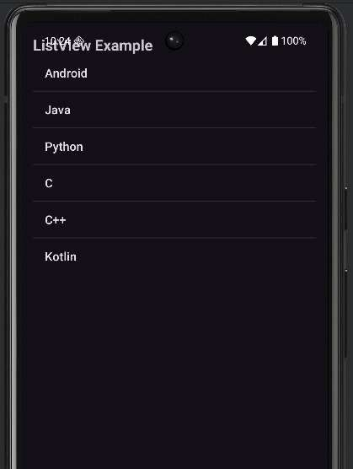

GridView activity_main.xml

<?xml version="1.0" encoding="utf-8"?>
<LinearLayout xmlns:android="http://schemas.android.com/apk/res/android" android:layout_width="match_parent" android:layout_height="match_parent"
android:orientation="vertical" android:padding="16dp">

<TextView android:layout_width="wrap_content" android:layout_height="wrap_content" android:text="GridView Example" android:textSize="20sp" android:textStyle="bold" />

<GridView android:id="@+id/gridView" android:layout_width="match_parent"
android:layout_height="wrap_content" android:numColumns="2" android:verticalSpacing="10dp" android:horizontalSpacing="10dp" android:stretchMode="columnWidth" android:gravity="center" />
</LinearLayout>

MainActivity.java
package com.example.gridview;

import android.os.Bundle;
import android.widget.ArrayAdapter; import android.widget.GridView;
import androidx.appcompat.app.AppCompatActivity;

public class MainActivity extends AppCompatActivity { GridView gridView;
@Override
protected void onCreate(Bundle savedInstanceState) { super.onCreate(savedInstanceState); setContentView(R.layout.activity_main);
gridView = findViewById(R.id.gridView); String[] items = {
"Android", "Java",
"Python",
"C",
"C++",
"Kotlin"
};
ArrayAdapter<String> adapter = new ArrayAdapter<>(this,
android.R.layout.simple_list_item_1, items);
gridView.setAdapter(adapter);
}
}

Output:
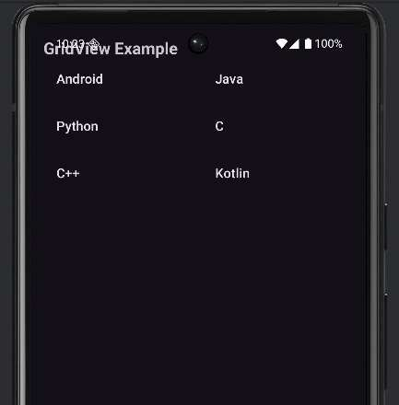

FrameLayout activity_main.xml
<?xml version="1.0" encoding="utf-8"?>
<FrameLayout xmlns:android="http://schemas.android.com/apk/res/android" android:layout_width="match_parent" android:layout_height="match_parent">
<TextView android:layout_width="match_parent" android:layout_height="match_parent" android:text="Background Text" android:textSize="22sp" android:gravity="center" android:background="#FFC107" android:textColor="#000000" />
<Button
android:layout_width="200dp" android:layout_height="wrap_content" android:text="Click Me" android:layout_gravity="center" />
</FrameLayout>

MainActivity.java
package com.example.framelayout; import android.os.Bundle;
import androidx.appcompat.app.AppCompatActivity; public class MainActivity extends AppCompatActivity {
@Override
protected void onCreate(Bundle savedInstanceState) { super.onCreate(savedInstanceState); setContentView(R.layout.activity_main);
}}
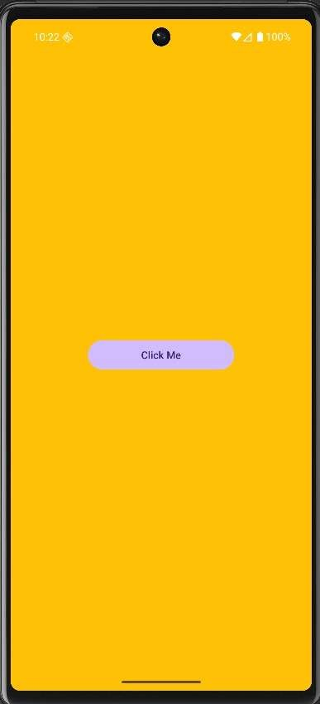
Output:

Practical 4
4 ] Programming UI elements AppBar, Fragments, UI Components UI elements AppBar
activity_main.xml
<?xml version="1.0" encoding="utf-8"?>
<LinearLayout xmlns:android="http://schemas.android.com/apk/res/android" xmlns:app="http://schemas.android.com/apk/res-auto" android:orientation="vertical"
android:layout_width="match_parent" android:layout_height="match_parent">

<androidx.appcompat.widget.Toolbar android:id="@+id/toolbar" android:layout_width="match_parent" android:layout_height="?attr/actionBarSize" android:background="#6200EE" android:title="My AppBar" android:titleTextColor="#FFFFFF"
app:titleTextAppearance="@style/TextAppearance.AppCompat.Large" />

<LinearLayout android:orientation="vertical" android:layout_width="match_parent" android:layout_height="match_parent" android:padding="16dp">

<TextView android:layout_width="wrap_content" android:layout_height="wrap_content" android:text="Welcome to the App!" android:textSize="20sp" android:paddingBottom="10dp"/>

<Button
android:layout_width="wrap_content" android:layout_height="wrap_content" android:text="Click Me" />

</LinearLayout>
</LinearLayout>

MainActivity.java
package com.example.pract4;

import android.os.Bundle;
import androidx.appcompat.app.AppCompatActivity; import androidx.appcompat.widget.Toolbar;

public class MainActivity extends AppCompatActivity { @Override
protected void onCreate(Bundle savedInstanceState) { super.onCreate(savedInstanceState); setContentView(R.layout.activity_main);

Toolbar toolbar = findViewById(R.id.toolbar); setSupportActionBar(toolbar);
}
}

output:

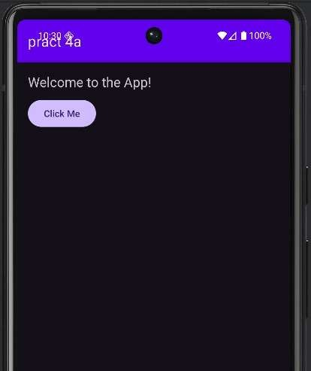

Fragments activity_main.xml
<?xml version="1.0" encoding="utf-8"?>
<FrameLayout xmlns:android="http://schemas.android.com/apk/res/android" android:id="@+id/fragmentContainer" android:layout_width="match_parent" android:layout_height="match_parent">
</FrameLayout>

fragment_example.xml
<?xml version="1.0" encoding="utf-8"?>
<LinearLayout xmlns:android="http://schemas.android.com/apk/res/android" android:layout_width="match_parent" android:layout_height="match_parent"
android:orientation="vertical" android:padding="16dp">
<TextView android:id="@+id/textViewFragment" android:layout_width="wrap_content" android:layout_height="wrap_content" android:text="Hello from Fragment!" android:textSize="20sp" android:paddingBottom="10dp"/>
<Button
android:id="@+id/buttonFragment" android:layout_width="wrap_content" android:layout_height="wrap_content" android:text="Click Me"/>
</LinearLayout>

examplefragment.java package com.example.pract4b; import android.os.Bundle;
import android.view.LayoutInflater; import android.view.View;
import android.view.ViewGroup; import android.widget.Button; import android.widget.Toast;
import androidx.annotation.NonNull; import androidx.annotation.Nullable; import androidx.fragment.app.Fragment;

public class ExampleFragment extends Fragment { @Nullable
@Override
public View onCreateView(@NonNull LayoutInflater inflater, @Nullable ViewGroup container,
@Nullable Bundle savedInstanceState) {
// Inflate the fragment layout
View view = inflater.inflate(R.layout.fragment_example, container, false); Button button = view.findViewById(R.id.buttonFragment); button.setOnClickListener(v ->
Toast.makeText(getActivity(), "Button clicked in Fragment!", Toast.LENGTH_SHORT).show()
);

return view;
}
}

MainActivity.java
package com.example.pract4b; import android.os.Bundle;
import android.view.LayoutInflater; import android.view.View;
import android.view.ViewGroup; import android.widget.Button; import android.widget.Toast;
import androidx.annotation.NonNull; import androidx.annotation.Nullable; import androidx.fragment.app.Fragment;
public class examplefragment extends Fragment{ @Nullable
@Override
public View onCreateView(@NonNull LayoutInflater inflater, @Nullable ViewGroup container,
@Nullable Bundle savedInstanceState) {
View view = inflater.inflate(R.layout.fragment_example, container, false); Button button = view.findViewById(R.id.buttonFragment); button.setOnClickListener(v ->
Toast.makeText(getActivity(), "Button clicked in Fragment!", Toast.LENGTH_SHORT).show()
);
return view;
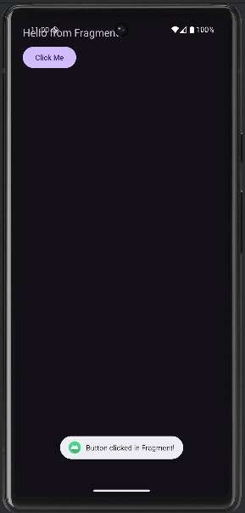
}
}

output:

UI components:
activity_main.xml
<?xml version="1.0" encoding="utf-8"?>
<LinearLayout xmlns:android="http://schemas.android.com/apk/res/android" android:layout_width="match_parent" android:layout_height="match_parent"
android:orientation="vertical" android:padding="16dp">
<EditText android:id="@+id/editTextName" android:layout_width="match_parent" android:layout_height="wrap_content" android:hint="Enter your name" />
<Button
android:id="@+id/btnSubmit" android:layout_width="wrap_content" android:layout_height="wrap_content" android:text="Submit" android:layout_marginTop="10dp" />
<ImageButton android:id="@+id/imageButton" android:layout_width="wrap_content" android:layout_height="wrap_content" android:src="@drawable/image1"
android:contentDescription="Camera Button" android:layout_marginTop="10dp" />
<CheckBox android:id="@+id/checkBox" android:layout_width="wrap_content" android:layout_height="wrap_content" android:text="I agree to terms" android:layout_marginTop="10dp" />
<RadioGroup android:id="@+id/radioGroup" android:layout_width="wrap_content" android:layout_height="wrap_content" android:layout_marginTop="10dp">
<RadioButton android:id="@+id/radioMale" android:layout_width="wrap_content" android:layout_height="wrap_content" android:text="Male" />
<RadioButton android:id="@+id/radioFemale" android:layout_width="wrap_content" android:layout_height="wrap_content" android:text="Female" />
</RadioGroup>
<ToggleButton android:id="@+id/toggleButton" android:layout_width="wrap_content" android:layout_height="wrap_content" android:textOn="ON" android:textOff="OFF" android:layout_marginTop="10dp" />
</LinearLayout>

MainActivity.java
package com.example.pract4c; import android.os.Bundle; import android.widget.*;
import androidx.appcompat.app.AppCompatActivity; public class MainActivity extends AppCompatActivity {
EditText editText; Button button;
ImageButton imageButton; CheckBox checkBox; RadioGroup radioGroup; ToggleButton toggleButton; @Override
protected void onCreate(Bundle savedInstanceState) { super.onCreate(savedInstanceState); setContentView(R.layout.activity_main);
editText = findViewById(R.id.editTextName); button = findViewById(R.id.btnSubmit); imageButton = findViewById(R.id.imageButton); checkBox = findViewById(R.id.checkBox); radioGroup = findViewById(R.id.radioGroup); toggleButton = findViewById(R.id.toggleButton); button.setOnClickListener(v -> {
String name = editText.getText().toString();
Toast.makeText(this, "Name: " + name, Toast.LENGTH_SHORT).show();
});
imageButton.setOnClickListener(v ->
Toast.makeText(this, "ImageButton Clicked", Toast.LENGTH_SHORT).show()
);
toggleButton.setOnCheckedChangeListener((buttonView, isChecked) -> { if (isChecked)
Toast.makeText(this, "Toggle ON", Toast.LENGTH_SHORT).show(); else
Toast.makeText(this, "Toggle OFF", Toast.LENGTH_SHORT).show();
});
}
}

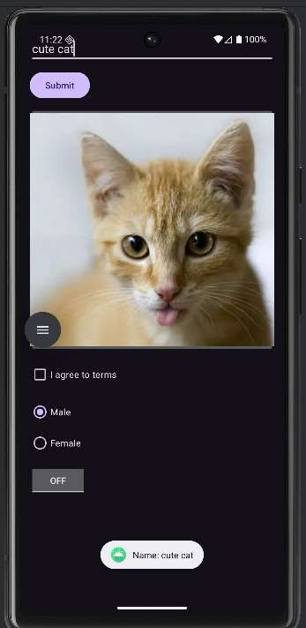
Output:

Practical 5 5] Programming menus, dialog, dialog fragments Menus:
Make sure your project structure looks exactly like this:Menu_main.xml app
└── src
└── main
├── java
│ └── com.example.prac5amenus
│ └── MainActivity.java
└── res
├── layout
│ └── activity_main.xml
└── menu
└── menu_main.xml

activity_main.xml
<?xml version="1.0" encoding="utf-8"?>
<LinearLayout xmlns:android="http://schemas.android.com/apk/res/android" android:layout_width="match_parent" android:layout_height="match_parent"
android:gravity="center" android:orientation="vertical">
<TextView android:layout_width="wrap_content" android:layout_height="wrap_content" android:text="Menu with Five Items" android:textSize="20sp" />
</LinearLayout>

AndriodManifest.xml
<?xml version="1.0" encoding="utf-8"?>
<manifest xmlns:android="http://schemas.android.com/apk/res/android" xmlns:tools="http://schemas.android.com/tools">
<application android:allowBackup="true"
android:dataExtractionRules="@xml/data_extraction_rules" android:fullBackupContent="@xml/backup_rules" android:icon="@mipmap/ic_launcher" android:label="@string/app_name" android:roundIcon="@mipmap/ic_launcher_round" android:supportsRtl="true" android:theme="@style/Theme.Prac5aMenus">
<activity android:name=".MainActivity" android:exported="true">
<intent-filter>
<action android:name="android.intent.action.MAIN" />
<category android:name="android.intent.category.LAUNCHER"/>
</intent-filter>
</activity>
</application>
</manifest>

Themes.xml
<resources xmlns:tools="http://schemas.android.com/tools">
<style name="Base.Theme.Prac5aMenus" parent="Theme.MaterialComponents.DayNight.DarkActionBar">
<!-- Customize your theme here -->
</style>
<style name="Theme.Prac5aMenus" parent="Base.Theme.Prac5aMenus" />
</resources>

MainActivity.java
package com.example.prcat5a;

import android.os.Bundle; import android.view.Menu; import android.view.MenuItem; import android.widget.Toast;
import androidx.appcompat.app.AppCompatActivity; public class MainActivity extends AppCompatActivity {
@Override
protected void onCreate(Bundle savedInstanceState) { super.onCreate(savedInstanceState); setContentView(R.layout.activity_main);
}
// Create menu
@Override
public boolean onCreateOptionsMenu(Menu menu) { getMenuInflater().inflate(R.menu.menu_main, menu); return true;
}
// Handle menu item selection
@Override
public boolean onOptionsItemSelected(MenuItem item) { int id = item.getItemId();
if (id == R.id.menu_home) {
Toast.makeText(this, "Home Selected", Toast.LENGTH_SHORT).show(); return true;
} else if (id == R.id.menu_profile) {
Toast.makeText(this, "Profile Selected", Toast.LENGTH_SHORT).show(); return true;
} else if (id == R.id.menu_settings) {
Toast.makeText(this, "Settings Selected", Toast.LENGTH_SHORT).show(); return true;
} else if (id == R.id.menu_help) {
Toast.makeText(this, "Help Selected", Toast.LENGTH_SHORT).show(); return true;
} else if (id == R.id.menu_exit) { finish();
return true;
}
return super.onOptionsItemSelected(item);
}
}

menu_main.xml
<?xml version="1.0" encoding="utf-8"?>
<menu xmlns:android="http://schemas.android.com/apk/res/android">

<item
android:id="@+id/menu_home" android:title="Home" />

<item
android:id="@+id/menu_profile" android:title="Profile" />

<item
android:id="@+id/menu_settings" android:title="Settings" />

<item
android:id="@+id/menu_help" android:title="Help" />

<item
android:id="@+id/menu_exit" android:title="Exit" />
</menu>
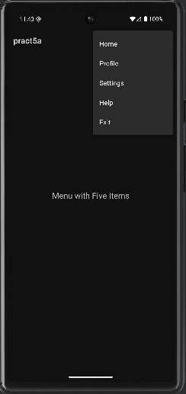
Output:

Dialog:
activity_main.xml
<?xml version="1.0" encoding="utf-8"?>
<LinearLayout xmlns:android="http://schemas.android.com/apk/res/android" android:orientation="vertical"
android:gravity="center" android:padding="20dp" android:layout_width="match_parent" android:layout_height="match_parent">
<Button
android:id="@+id/btnDatePicker" android:layout_width="wrap_content" android:layout_height="wrap_content" android:text="Select Date" android:layout_marginBottom="20dp"/>
<Button
android:id="@+id/btnTimePicker" android:layout_width="wrap_content" android:layout_height="wrap_content" android:text="Select Time"/>
</LinearLayout>

MainActivity.java
package com.example.pract5b;
import android.app.DatePickerDialog; import android.app.TimePickerDialog; import android.os.Bundle;
import android.widget.Button; import android.widget.DatePicker; import android.widget.TimePicker; import android.widget.Toast;
import androidx.appcompat.app.AppCompatActivity; import java.util.Calendar;

public class MainActivity extends AppCompatActivity { Button btnDatePicker, btnTimePicker;
@Override
protected void onCreate(Bundle savedInstanceState) { super.onCreate(savedInstanceState); setContentView(R.layout.activity_main); btnDatePicker = findViewById(R.id.btnDatePicker); btnTimePicker = findViewById(R.id.btnTimePicker);
// DATE PICKER
btnDatePicker.setOnClickListener(v -> { Calendar calendar = Calendar.getInstance(); int year = calendar.get(Calendar.YEAR);
int month = calendar.get(Calendar.MONTH);
int day = calendar.get(Calendar.DAY_OF_MONTH);

DatePickerDialog datePickerDialog = new DatePickerDialog( MainActivity.this,
(view, selectedYear, selectedMonth, selectedDay) -> {
// Note: Month starts from 0, so add 1
String date = selectedDay + "/" + (selectedMonth + 1) + "/" + selectedYear;

Toast.makeText(MainActivity.this, "Selected Date: " + date, Toast.LENGTH_SHORT).show();
},
year, month, day
);
datePickerDialog.show();
});
// TIME PICKER
btnTimePicker.setOnClickListener(v -> { Calendar calendar = Calendar.getInstance();
int hour = calendar.get(Calendar.HOUR_OF_DAY); int minute = calendar.get(Calendar.MINUTE);
TimePickerDialog timePickerDialog = new TimePickerDialog( MainActivity.this,
(view, selectedHour, selectedMinute) -> {
String time = selectedHour + ":" + String.format("%02d", selectedMinute); Toast.makeText(MainActivity.this, "Selected Time: " + time,
Toast.LENGTH_SHORT).show();
},
hour, minute, true // true = 24-hour format
);
timePickerDialog.show();
});
}
}

Output:
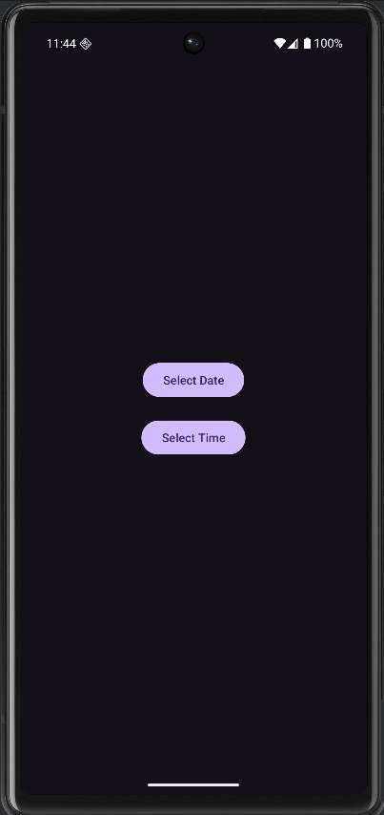
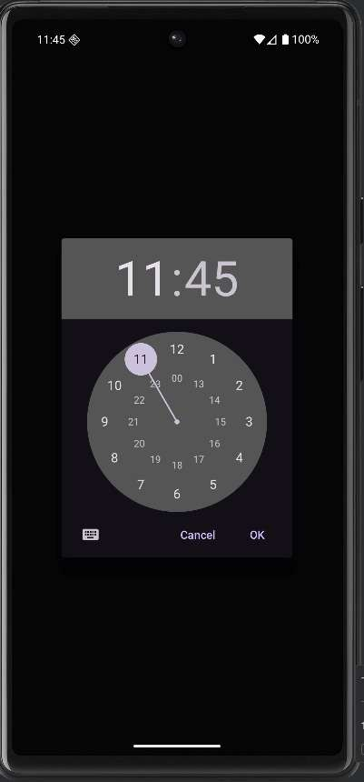
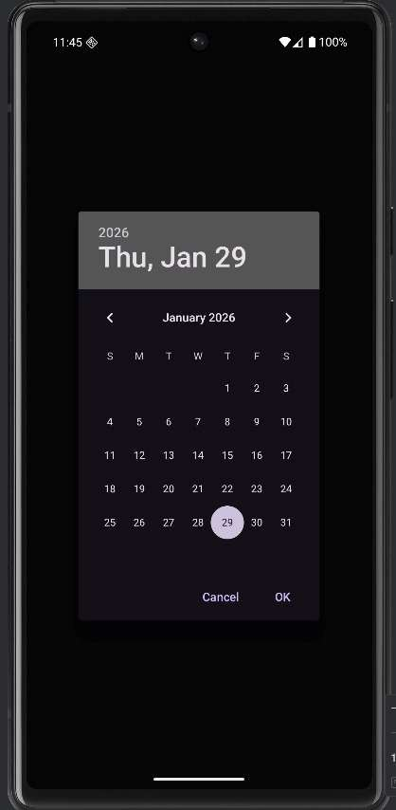

Dialog Fragments:
app/
└── java/com/example/dialogdemo/
├── MainActivity.java
└── ButtonDialogFragment.java
└── res/
└── layout/
├── activity_main.xml
└── dialog_button.xml

activity_main.xml
<?xml version="1.0" encoding="utf-8"?>
<LinearLayout xmlns:android="http://schemas.android.com/apk/res/android" android:layout_width="match_parent" android:layout_height="match_parent"
android:orientation="vertical" android:gravity="center" android:padding="24dp">
<Button
android:id="@+id/btnOne" android:layout_width="match_parent" android:layout_height="wrap_content" android:text="Button One" />
<Button
android:id="@+id/btnTwo" android:layout_width="match_parent" android:layout_height="wrap_content" android:text="Button Two" android:layout_marginTop="16dp" />
</LinearLayout>

ButtonDialogFragment.java package com.example.pract5c; import android.os.Bundle;
import android.view.LayoutInflater; import android.view.View;
import android.view.ViewGroup; import android.widget.Button; import android.widget.TextView; import androidx.annotation.NonNull; import androidx.annotation.Nullable;
import androidx.fragment.app.DialogFragment;

public class ButtonDialogFragment extends DialogFragment { private static final String ARG_MESSAGE = "message";
public static ButtonDialogFragment newInstance(String message) { ButtonDialogFragment fragment = new ButtonDialogFragment(); Bundle bundle = new Bundle(); bundle.putString(ARG_MESSAGE, message); fragment.setArguments(bundle);
return fragment;
}
@Nullable @Override
public View onCreateView( @NonNull LayoutInflater inflater, @Nullable ViewGroup container,
@Nullable Bundle savedInstanceState) {
View view = inflater.inflate(R.layout.dialog_button, container, false);

TextView tvMessage = view.findViewById(R.id.tvMessage); Button btnOk = view.findViewById(R.id.btnOk);
if (getArguments() != null) { tvMessage.setText(getArguments().getString(ARG_MESSAGE));
}
btnOk.setOnClickListener(v -> dismiss()); return view;
}
}

MainActivity.java
package com.example.pract5c;

import android.os.Bundle; import android.widget.Button;
import androidx.appcompat.app.AppCompatActivity; public class MainActivity extends AppCompatActivity {
@Override
protected void onCreate(Bundle savedInstanceState) { super.onCreate(savedInstanceState); setContentView(R.layout.activity_main);
Button btnOne = findViewById(R.id.btnOne); Button btnTwo = findViewById(R.id.btnTwo); btnOne.setOnClickListener(v ->
showDialog("Button One clicked")
);
btnTwo.setOnClickListener(v -> showDialog("Button Two clicked")
);
}
private void showDialog(String message) { ButtonDialogFragment dialog =
ButtonDialogFragment.newInstance(message); dialog.show(getSupportFragmentManager(), "ButtonDialog");
}
}

dialog_button.xml
<?xml version="1.0" encoding="utf-8"?>
<LinearLayout xmlns:android="http://schemas.android.com/apk/res/android" android:layout_width="match_parent" android:layout_height="wrap_content"
android:orientation="vertical" android:padding="24dp">
<TextView android:id="@+id/tvMessage" android:layout_width="match_parent" android:layout_height="wrap_content" android:textSize="18sp"
android:textColor="@android:color/black" android:text="Button Clicked" android:paddingBottom="16dp"/>
<Button
android:id="@+id/btnOk" android:layout_width="match_parent" android:layout_height="wrap_content" android:text="OK"/>
</LinearLayout>

Themes.xml

<resources xmlns:tools="http://schemas.android.com/tools">
<style name="Theme.Prac5AMenus" parent="Theme.AppCompat.DayNight.DarkActionBar">
</style>
<style name="Theme.Prac5aMenus" parent="Base.Theme.Pract5c" />
</resources>

AndriodManifest.xml
<?xml version="1.0" encoding="utf-8"?>
<manifest xmlns:android="http://schemas.android.com/apk/res/android" xmlns:tools="http://schemas.android.com/tools">
<application android:allowBackup="true"
android:dataExtractionRules="@xml/data_extraction_rules" android:fullBackupContent="@xml/backup_rules" android:icon="@mipmap/ic_launcher" android:label="@string/app_name" android:roundIcon="@mipmap/ic_launcher_round" android:supportsRtl="true" android:theme="@style/Theme.Prac5AMenus">
<activity android:name=".MainActivity" android:exported="true">
<intent-filter>
<action android:name="android.intent.action.MAIN" />
<category android:name="android.intent.category.LAUNCHER"/>
</intent-filter>
</activity>
</application>
</manifest>
Output:
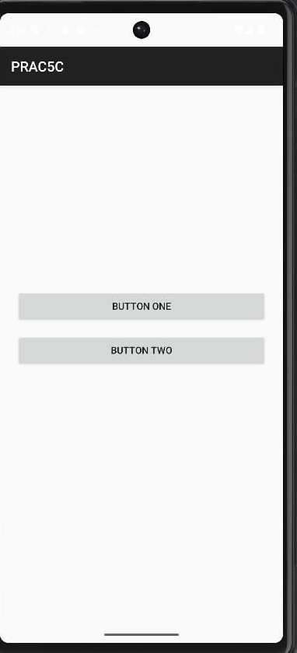
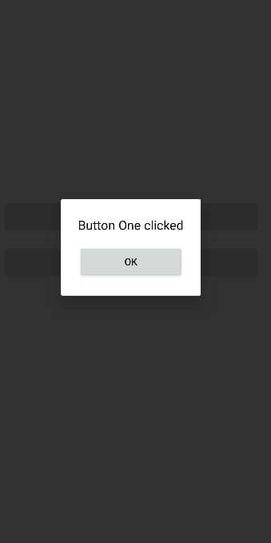

Practical 6
Programs on Intents, Events, Listeners and Adapters The Android Intent Class, Using Events and Event Listeners
activity_main.xml
<?xml version="1.0" encoding="utf-8"?>
<LinearLayout xmlns:android="http://schemas.android.com/apk/res/android" android:layout_width="match_parent" android:layout_height="match_parent"
android:gravity="center" android:orientation="vertical">
<Button
android:id="@+id/btnNext" android:layout_width="wrap_content" android:layout_height="wrap_content" android:text="Go to Second Activity"/>
</LinearLayout>
Activity_second.xml
<?xml version="1.0" encoding="utf-8"?>
<LinearLayout xmlns:android="http://schemas.android.com/apk/res/android" android:layout_width="match_parent" android:layout_height="match_parent"
android:gravity="center" android:orientation="vertical">
<TextView android:layout_width="wrap_content" android:layout_height="wrap_content" android:text="Welcome to Second Activity" android:textSize="20sp"/>
</LinearLayout>
MainActivity.java
package com.example.pract6; import android.content.Intent; import android.os.Bundle; import android.view.View; import android.widget.Button;
import androidx.appcompat.app.AppCompatActivity;

public class MainActivity extends AppCompatActivity { Button btnNext;
@Override
protected void onCreate(Bundle savedInstanceState) { super.onCreate(savedInstanceState); setContentView(R.layout.activity_main);
btnNext = findViewById(R.id.btnNext); btnNext.setOnClickListener(new View.OnClickListener() {
@Override
public void onClick(View v) {
Intent intent = new Intent(MainActivity.this, secondactivity.class); startActivity(intent);
}
});
}
}
secondactivity.java
package com.example.pract6; import android.os.Bundle;
import androidx.appcompat.app.AppCompatActivity;

public class secondactivity extends AppCompatActivity { @Override

protected void onCreate(Bundle savedInstanceState) { super.onCreate(savedInstanceState); setContentView(R.layout.activity_second);
}
}
AndriodManifest.xml
<?xml version="1.0" encoding="utf-8"?>
<manifest xmlns:tools="http://schemas.android.com/tools" xmlns:android="http://schemas.android.com/apk/res/android" tools:ignore="ExtraText">
<application android:allowBackup="true" android:icon="@mipmap/ic_launcher" android:label="@string/app_name"
android:theme="@style/Theme.Prac5AMenus" tools:targetApi="31">
<activity android:name=".secondactivity" android:exported="false" />
<activity android:name=".MainActivity" android:exported="true">
<intent-filter>
<action android:name="android.intent.action.MAIN" />
<category android:name="android.intent.category.LAUNCHER" />
</intent-filter>
</activity>
</application>
</manifest>

Themes.xml
<?xml version="1.0" encoding="utf-8"?>
<resources xmlns:tools="http://schemas.android.com/tools">
<style name="Theme.Prac5AMenus" parent="Theme.AppCompat.DayNight.DarkActionBar">
</style>
</resources>

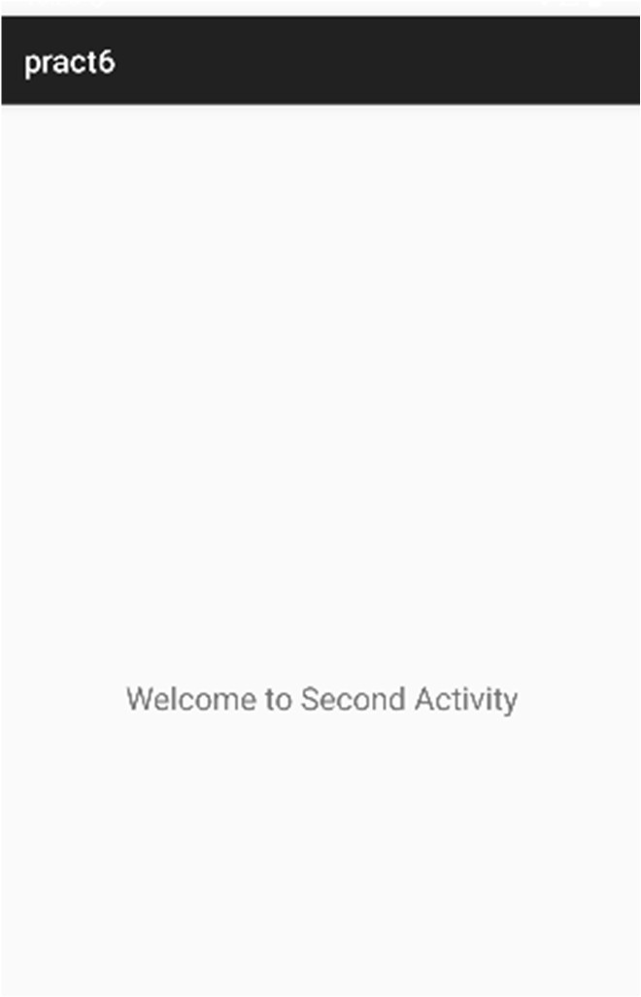
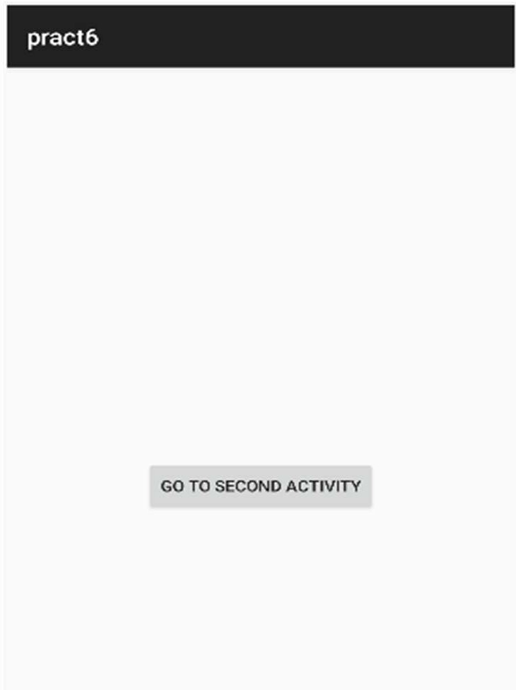
Output:

Practical 7 Programs on Services, notification and broadcast receivers MyService.java
package com.example.practical7;
import android.app.Service; import android.content.Intent; import android.os.IBinder; import android.util.Log; import android.widget.Toast;
import androidx.annotation.Nullable;

public class MyService extends Service { private static final String TAG = "MyService"; @Override
public void onCreate() { super.onCreate();
Toast.makeText(this, "Service Created", Toast.LENGTH_SHORT).show(); Log.d(TAG, "onCreate()");
}@Override
public int onStartCommand(Intent intent, int flags, int startId) { Toast.makeText(this, "Service Started", Toast.LENGTH_SHORT).show(); Log.d(TAG, "onStartCommand()");
return START_STICKY;
}@Nullable @Override
public IBinder onBind(Intent intent) {
Toast.makeText(this, "Service Bound", Toast.LENGTH_SHORT).show(); Log.d(TAG, "onBind()");
return null; // No binding object used
}@Override
public boolean onUnbind(Intent intent) {
Toast.makeText(this, "Service Unbound", Toast.LENGTH_SHORT).show(); Log.d(TAG, "onUnbind()");
return true; // Allows onRebind() to be called
}@Override
public void onRebind(Intent intent) { super.onRebind(intent);
Toast.makeText(this, "Service Rebound", Toast.LENGTH_SHORT).show(); Log.d(TAG, "onRebind()");
}@Override
public void onDestroy() { super.onDestroy();
Toast.makeText(this, "Service Destroyed", Toast.LENGTH_SHORT).show(); Log.d(TAG, "onDestroy()");
}
}

MainActivity.java
package com.example.practical7; import android.content.Intent;
import android.content.ServiceConnection; import android.content.ComponentName; import android.os.Bundle;
import android.os.IBinder; import android.view.View; import android.widget.Button;
import androidx.appcompat.app.AppCompatActivity;

public class MainActivity extends AppCompatActivity { Button startBtn, stopBtn, bindBtn, unbindBtn;
Intent serviceIntent; boolean isBound = false;
ServiceConnection serviceConnection = new ServiceConnection() { @Override
public void onServiceConnected(ComponentName name, IBinder service) { isBound = true;
}
@Override
public void onServiceDisconnected(ComponentName name) { isBound = false;
}
};

@Override
protected void onCreate(Bundle savedInstanceState) { super.onCreate(savedInstanceState); setContentView(R.layout.activity_main);

startBtn = findViewById(R.id.startService); stopBtn = findViewById(R.id.stopService); bindBtn = findViewById(R.id.bindService); unbindBtn = findViewById(R.id.unbindService);

serviceIntent = new Intent(this, MyService.class);

startBtn.setOnClickListener(v -> startService(serviceIntent)); stopBtn.setOnClickListener(v -> stopService(serviceIntent));

bindBtn.setOnClickListener(v -> { if (!isBound) {
bindService(serviceIntent, serviceConnection, BIND_AUTO_CREATE); isBound = true;
}
});
unbindBtn.setOnClickListener(v -> { if (isBound) {
unbindService(serviceConnection); isBound = false;
}
});
}
}

activity_main.xml
<?xml version="1.0" encoding="utf-8"?>
<LinearLayout xmlns:android="http://schemas.android.com/apk/res/android" android:layout_width="match_parent" android:layout_height="match_parent"
android:orientation="vertical" android:gravity="center">

<Button
android:id="@+id/startService" android:text="Start Service" android:layout_width="wrap_content" android:layout_height="wrap_content"/>

<Button
android:id="@+id/bindService" android:text="Bind Service" android:layout_width="wrap_content" android:layout_height="wrap_content"/>

<Button
android:id="@+id/unbindService" android:text="Unbind Service" android:layout_width="wrap_content" android:layout_height="wrap_content"/>

<Button
android:id="@+id/stopService" android:text="Stop Service" android:layout_width="wrap_content" android:layout_height="wrap_content"/>
</LinearLayout>

AndroidManifest.xml
<?xml version="1.0" encoding="utf-8"?>
<manifest xmlns:android="http://schemas.android.com/apk/res/android" package="com.example.practical7">
<application android:allowBackup="true" android:icon="@mipmap/ic_launcher" android:label="@string/app_name"
android:theme="@style/Theme.AppCompat.Light.DarkActionBar">
<activity android:name=".MainActivity" android:exported="true">
<intent-filter>
<action android:name="android.intent.action.MAIN"/>
<category android:name="android.intent.category.LAUNCHER"/>
</intent-filter>
</activity>
<service android:name=".MyService" android:exported="false"/>
</application>
</manifest>

AndroidManifest.xml – add this
<service android:name=".MyService" />

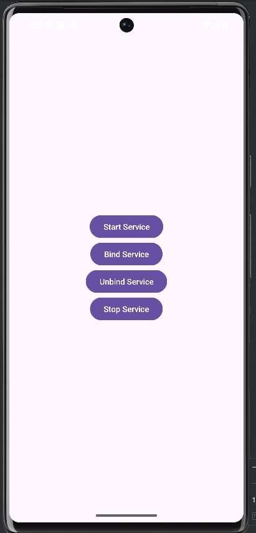
Output:

Download a notification image and save the file as ic_notification.png Add this image in the drawable.

MainActivity.java
package com.example.notificationdemo; import android.Manifest;
import android.app.NotificationChannel; import android.app.NotificationManager; import android.content.pm.PackageManager; import android.os.Build;
import android.os.Bundle; import android.widget.Button;
import androidx.appcompat.app.AppCompatActivity; import androidx.core.app.ActivityCompat;
import androidx.core.app.NotificationCompat;
import androidx.core.app.NotificationManagerCompat;

public class MainActivity extends AppCompatActivity { private static final String CHANNEL_ID = "MyChannel"; @Override
protected void onCreate(Bundle savedInstanceState) { super.onCreate(savedInstanceState); setContentView(R.layout.activity_main);
Button notifyBtn = findViewById(R.id.btnNotify); createNotificationChannel();
if (Build.VERSION.SDK_INT >= Build.VERSION_CODES.TIRAMISU) {
ActivityCompat.requestPermissions(this,
new String[]{Manifest.permission.POST_NOTIFICATIONS}, 101);
}
notifyBtn.setOnClickListener(v -> { NotificationCompat.Builder builder =
new NotificationCompat.Builder(this, CHANNEL_ID)
.setSmallIcon(android.R.drawable.ic_dialog_info)
.setContentTitle("Notification Title")
.setContentText("This is a simple notification")
.setPriority(NotificationCompat.PRIORITY_DEFAULT); NotificationManagerCompat manager =
NotificationManagerCompat.from(this); if (ActivityCompat.checkSelfPermission(this,
Manifest.permission.POST_NOTIFICATIONS)
!= PackageManager.PERMISSION_GRANTED) { return;
}
manager.notify(1, builder.build());
});
}
private void createNotificationChannel() {
if (Build.VERSION.SDK_INT >= Build.VERSION_CODES.O) {

NotificationChannel channel = new NotificationChannel(
CHANNEL_ID,
"My Notification Channel", NotificationManager.IMPORTANCE_DEFAULT);
channel.setDescription("Channel for Demo"); NotificationManager manager =
getSystemService(NotificationManager.class); manager.createNotificationChannel(channel);
} } }

Activity_main.xml
<?xml version="1.0" encoding="utf-8"?>
<LinearLayout xmlns:android="http://schemas.android.com/apk/res/android" android:layout_width="match_parent" android:layout_height="match_parent" android:gravity="center"
android:orientation="vertical">
<Button
android:id="@+id/btnNotify" android:layout_width="wrap_content" android:layout_height="wrap_content" android:text="Show Notification"/>
</LinearLayout>

AndroidManifest.xml
<?xml version="1.0" encoding="utf-8"?>
<manifest xmlns:android="http://schemas.android.com/apk/res/android" package="com.example.notificationdemo">
<uses-permission android:name="android.permission.POST_NOTIFICATIONS"/>
<application android:allowBackup="true" android:icon="@mipmap/ic_launcher"
android:roundIcon="@mipmap/ic_launcher_round" android:label="@string/app_name" android:supportsRtl="true"
android:theme="@style/Theme.AppCompat.Light.DarkActionBar">
<activity android:name=".MainActivity" android:exported="true">
<intent-filter>
<action android:name="android.intent.action.MAIN"/>
<category android:name="android.intent.category.LAUNCHER"/>
</intent-filter>
</activity>
</application>
</manifest>
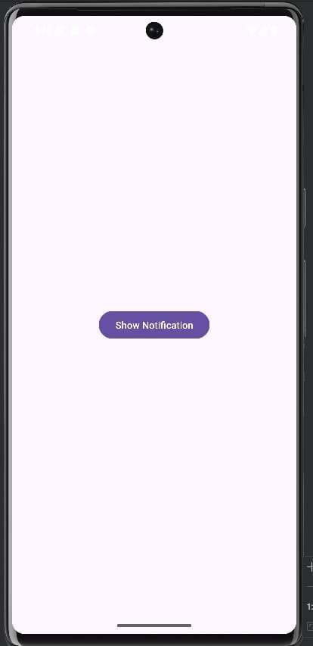
Output:

MainActivity.java
package com.example.airplanemodedemo;

import android.content.BroadcastReceiver; import android.content.Context;
import android.content.Intent; import android.content.IntentFilter; import android.os.Bundle;
import android.provider.Settings; import android.view.View; import android.widget.Button; import android.widget.TextView;
import androidx.appcompat.app.AppCompatActivity;

public class MainActivity extends AppCompatActivity { Button btnToggle;
TextView tvStatus;
AirplaneModeReceiver airplaneModeReceiver; @Override
protected void onCreate(Bundle savedInstanceState) { super.onCreate(savedInstanceState); setContentView(R.layout.activity_main); btnToggle = findViewById(R.id.btnToggle); tvStatus = findViewById(R.id.tvStatus);
btnToggle.setOnClickListener(new View.OnClickListener() { @Override
public void onClick(View v) {
Intent intent = new Intent(Settings.ACTION_AIRPLANE_MODE_SETTINGS); startActivity(intent);
}
});
boolean isOn = Settings.Global.getInt( getContentResolver(), Settings.Global.AIRPLANE_MODE_ON, 0) == 1;
tvStatus.setText(isOn ? "Airplane Mode ON" : "Airplane Mode OFF"); airplaneModeReceiver = new AirplaneModeReceiver(tvStatus);
IntentFilter filter = new IntentFilter(Intent.ACTION_AIRPLANE_MODE_CHANGED); registerReceiver(airplaneModeReceiver, filter);
}
@Override
protected void onDestroy() { super.onDestroy(); unregisterReceiver(airplaneModeReceiver);
}
}

AirplaneModeReceiver.java
package com.example.airplanemodedemo; import android.content.BroadcastReceiver; import android.content.Context;
import android.content.Intent; import android.widget.TextView;

public class AirplaneModeReceiver extends BroadcastReceiver { private TextView tvStatus;
// Constructor receives the TextView reference
public AirplaneModeReceiver(TextView tvStatus) { this.tvStatus = tvStatus;
}

@Override
public void onReceive(Context context, Intent intent) {
if (Intent.ACTION_AIRPLANE_MODE_CHANGED.equals(intent.getAction())) { boolean isOn = intent.getBooleanExtra("state", false);

// Update TextView on UI thread
tvStatus.post(new Runnable() { @Override
public void run() {
tvStatus.setText(isOn ? "Airplane Mode ON" : "Airplane Mode OFF");
}
});
}
}
}

activity_main.xml
<?xml version="1.0" encoding="utf-8"?>
<LinearLayout xmlns:android="http://schemas.android.com/apk/res/android" android:layout_width="match_parent" android:layout_height="match_parent"
android:orientation="vertical" android:gravity="center" android:padding="20dp">

<TextView android:id="@+id/tvStatus"
android:layout_width="wrap_content" android:layout_height="wrap_content" android:text="Airplane Mode Status" android:textSize="20sp" android:layout_marginBottom="30dp"/>

<Button
android:id="@+id/btnToggle" android:layout_width="wrap_content" android:layout_height="wrap_content" android:text="Open Airplane Mode Settings"/>
</LinearLayout>

Androidmanifest.xml
<?xml version="1.0" encoding="utf-8"?>
<manifest xmlns:android="http://schemas.android.com/apk/res/android">
<application android:allowBackup="true" android:label="AirplaneModeDemo"
android:theme="@style/Theme.AppCompat.Light.DarkActionBar">
<activity android:name=".MainActivity" android:exported="true">
<intent-filter>
<action android:name="android.intent.action.MAIN"/>
<category android:name="android.intent.category.LAUNCHER"/>
</intent-filter>
</activity>
</application>

</manifest>
Output:
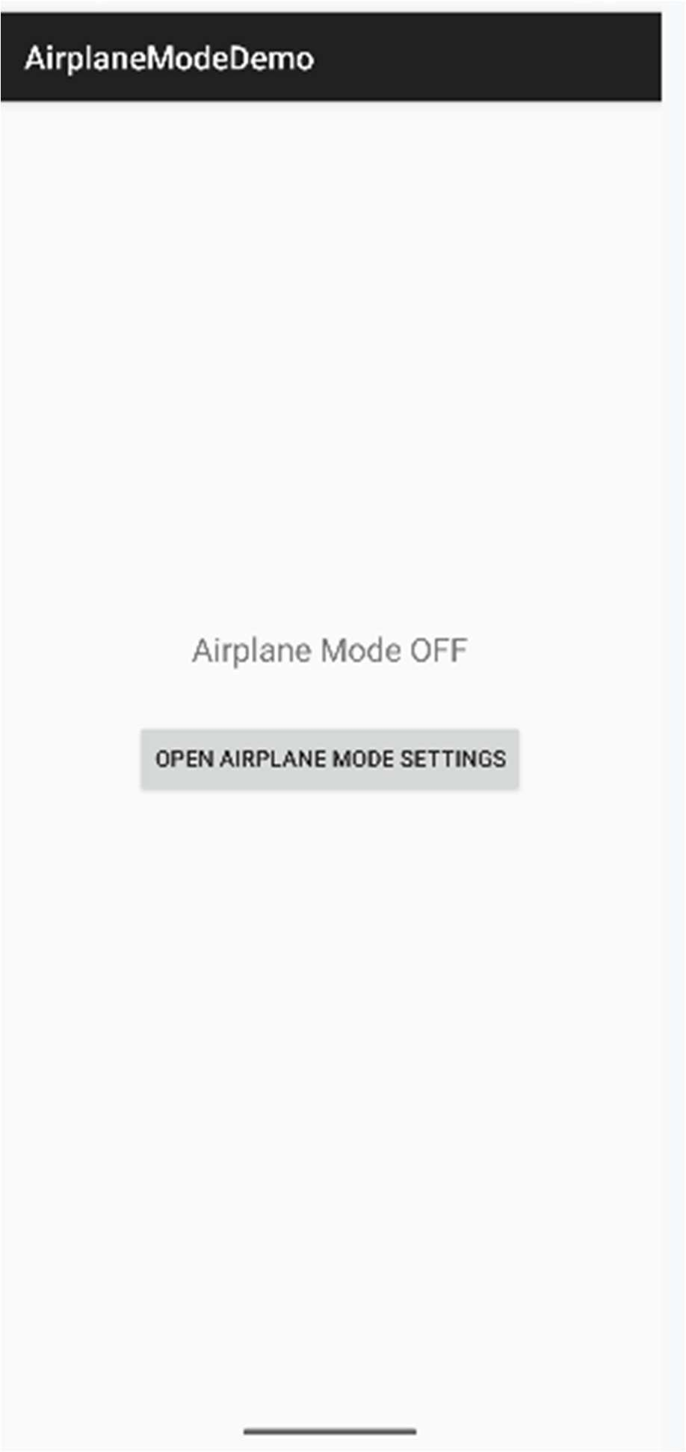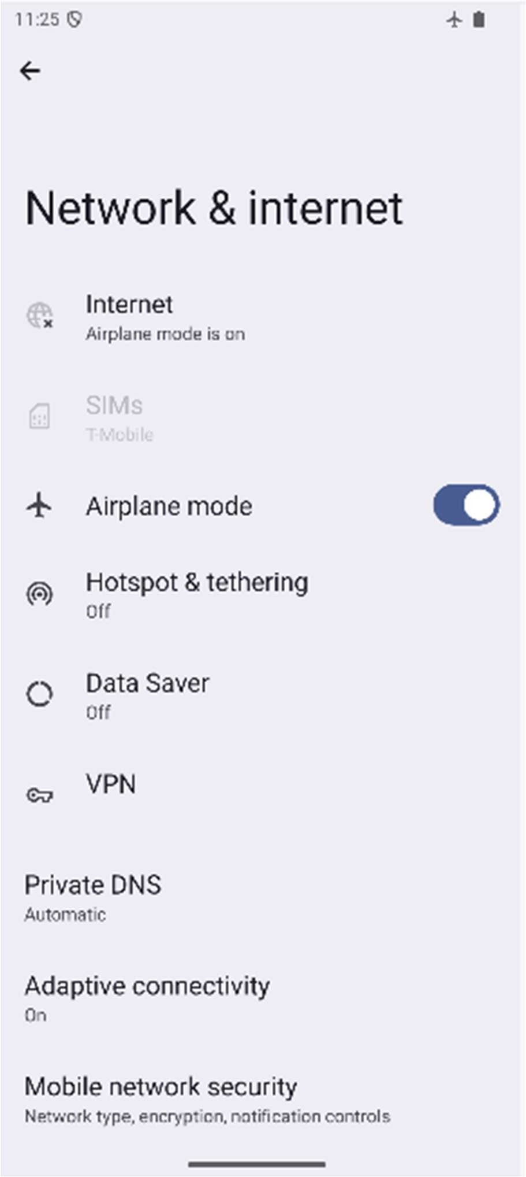

Practical 8
- Database Programming with SQLite Activity_main.xml
<?xml version="1.0" encoding="utf-8"?>
<LinearLayout xmlns:android="http://schemas.android.com/apk/res/android" android:layout_width="match_parent" android:layout_height="match_parent"
android:orientation="vertical" android:padding="20dp">

<EditText android:id="@+id/etName"
android:layout_width="match_parent" android:layout_height="wrap_content" android:hint="Enter Name" />

<EditText android:id="@+id/etPhone"
android:layout_width="match_parent" android:layout_height="wrap_content" android:hint="Enter Phone" android:inputType="phone" />

<Button
android:id="@+id/btnAdd" android:layout_width="match_parent" android:layout_height="wrap_content" android:text="Add Contact" android:layout_marginTop="10dp"/>

<Button
android:id="@+id/btnUpdate" android:layout_width="match_parent" android:layout_height="wrap_content" android:text="Update Contact" android:layout_marginTop="5dp"/>

<Button
android:id="@+id/btnDelete" android:layout_width="match_parent" android:layout_height="wrap_content" android:text="Delete Contact" android:layout_marginTop="5dp"/>

<Button
android:id="@+id/btnView" android:layout_width="match_parent" android:layout_height="wrap_content" android:text="View Contacts" android:layout_marginTop="10dp"/>

<ListView android:id="@+id/lvContacts" android:layout_width="match_parent" android:layout_height="wrap_content"

android:layout_marginTop="20dp"/>
</LinearLayout>

MainActivity.java
package com.example.pract8a; import android.database.Cursor; import android.os.Bundle; import android.view.View;
import android.widget.AdapterView; import android.widget.ArrayAdapter; import android.widget.Button; import android.widget.EditText; import android.widget.ListView; import android.widget.Toast;

import androidx.appcompat.app.AppCompatActivity; import java.util.ArrayList;
public class MainActivity extends AppCompatActivity {

EditText etName, etPhone;
Button btnAdd, btnUpdate, btnDelete, btnView; ListView lvContacts;

DatabaseHelper dbHelper; ArrayList<Integer> contactIds; int selectedId = -1;
@Override
protected void onCreate(Bundle savedInstanceState) { super.onCreate(savedInstanceState); setContentView(R.layout.activity_main);

etName = findViewById(R.id.etName); etPhone = findViewById(R.id.etPhone); btnAdd = findViewById(R.id.btnAdd); btnUpdate = findViewById(R.id.btnUpdate); btnDelete = findViewById(R.id.btnDelete); btnView = findViewById(R.id.btnView); lvContacts = findViewById(R.id.lvContacts);

dbHelper = new DatabaseHelper(this); contactIds = new ArrayList<>();

btnAdd.setOnClickListener(new View.OnClickListener() { @Override
public void onClick(View v) {

String name = etName.getText().toString().trim(); String phone = etPhone.getText().toString().trim();

if(name.isEmpty() || phone.isEmpty()) {
Toast.makeText(MainActivity.this, "Enter name and phone", Toast.LENGTH_SHORT).show(); return;
}

if(dbHelper.insertContact(name, phone)) {
Toast.makeText(MainActivity.this, "Contact added", Toast.LENGTH_SHORT).show(); etName.setText("");
etPhone.setText(""); loadContacts();
} else {
Toast.makeText(MainActivity.this, "Insertion failed", Toast.LENGTH_SHORT).show();
}
}
});

btnUpdate.setOnClickListener(new View.OnClickListener() { @Override
public void onClick(View v) {

if(selectedId == -1) {
Toast.makeText(MainActivity.this, "Select a contact first", Toast.LENGTH_SHORT).show(); return;
}

String name = etName.getText().toString().trim(); String phone = etPhone.getText().toString().trim();

if(name.isEmpty() || phone.isEmpty()) {
Toast.makeText(MainActivity.this, "Enter name and phone", Toast.LENGTH_SHORT).show(); return;
}

if(dbHelper.updateContact(selectedId, name, phone)) {
Toast.makeText(MainActivity.this, "Contact updated", Toast.LENGTH_SHORT).show(); etName.setText("");
etPhone.setText(""); selectedId = -1; loadContacts();
} else {
Toast.makeText(MainActivity.this, "Update failed", Toast.LENGTH_SHORT).show();
}
}
});

btnDelete.setOnClickListener(new View.OnClickListener() { @Override
public void onClick(View v) {

if(selectedId == -1) {
Toast.makeText(MainActivity.this, "Select a contact first", Toast.LENGTH_SHORT).show(); return;
}

if(dbHelper.deleteContact(selectedId)) {
Toast.makeText(MainActivity.this, "Contact deleted", Toast.LENGTH_SHORT).show(); etName.setText("");
etPhone.setText(""); selectedId = -1; loadContacts();

} else {
Toast.makeText(MainActivity.this, "Deletion failed", Toast.LENGTH_SHORT).show();
}
}
});

btnView.setOnClickListener(new View.OnClickListener() { @Override
public void onClick(View v) { loadContacts();
}
});

lvContacts.setOnItemClickListener(new AdapterView.OnItemClickListener() { @Override
public void onItemClick(AdapterView<?> adapterView, View view, int position, long l) { selectedId = contactIds.get(position);
Cursor cursor = dbHelper.getAllContacts(); if(cursor.moveToPosition(position)) {
etName.setText(cursor.getString(cursor.getColumnIndexOrThrow("name"))); etPhone.setText(cursor.getString(cursor.getColumnIndexOrThrow("phone")));
}
}
});

loadContacts();
}

private void loadContacts() {
Cursor cursor = dbHelper.getAllContacts(); ArrayList<String> list = new ArrayList<>(); contactIds.clear();

if(cursor.getCount() == 0) { list.add("No records found");
} else {
while(cursor.moveToNext()) {
int id = cursor.getInt(cursor.getColumnIndexOrThrow("id"));
String name = cursor.getString(cursor.getColumnIndexOrThrow("name")); String phone = cursor.getString(cursor.getColumnIndexOrThrow("phone"));

list.add(name + " - " + phone); contactIds.add(id);
}
}

ArrayAdapter<String> adapter = new ArrayAdapter<>(this, android.R.layout.simple_list_item_1, list);
lvContacts.setAdapter(adapter);
}
}

DatabaseHelper.java
package com.example.pract8a;

import android.content.ContentValues; import android.content.Context; import android.database.Cursor;
import android.database.sqlite.SQLiteDatabase; import android.database.sqlite.SQLiteOpenHelper;

public class DatabaseHelper extends SQLiteOpenHelper {

private static final String DATABASE_NAME = "Contacts.db"; private static final int DATABASE_VERSION = 1;

private static final String TABLE_NAME = "contacts"; private static final String COL_ID = "id";
private static final String COL_NAME = "name"; private static final String COL_PHONE = "phone";

public DatabaseHelper(Context context) {
super(context, DATABASE_NAME, null, DATABASE_VERSION);
}

@Override
public void onCreate(SQLiteDatabase db) {
String createTable = "CREATE TABLE " + TABLE_NAME + " (" + COL_ID + " INTEGER PRIMARY KEY AUTOINCREMENT, " + COL_NAME + " TEXT, " +
COL_PHONE + " TEXT)";
db.execSQL(createTable);
}

@Override
public void onUpgrade(SQLiteDatabase db, int oldVersion, int newVersion) { db.execSQL("DROP TABLE IF EXISTS " + TABLE_NAME);
onCreate(db);
}
public boolean insertContact(String name, String phone) { SQLiteDatabase db = this.getWritableDatabase(); ContentValues values = new ContentValues(); values.put(COL_NAME, name); values.put(COL_PHONE, phone);

long result = db.insert(TABLE_NAME, null, values); return result != -1;
}
public Cursor getAllContacts() {
SQLiteDatabase db = this.getReadableDatabase();
return db.rawQuery("SELECT * FROM " + TABLE_NAME, null);
}
public boolean updateContact(int id, String name, String phone) { SQLiteDatabase db = this.getWritableDatabase(); ContentValues values = new ContentValues(); values.put(COL_NAME, name);
values.put(COL_PHONE, phone);

int result = db.update(TABLE_NAME, values, "id=?", new String[]{String.valueOf(id)});
return result > 0;
}
public boolean deleteContact(int id) { SQLiteDatabase db = this.getWritableDatabase(); int result = db.delete(TABLE_NAME,
"id=?", new String[]{String.valueOf(id)}); return result > 0;
}
}

Output:
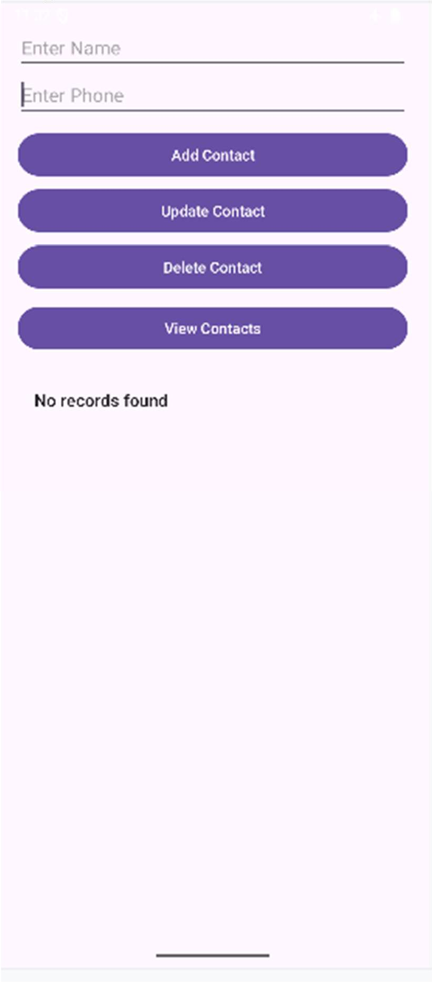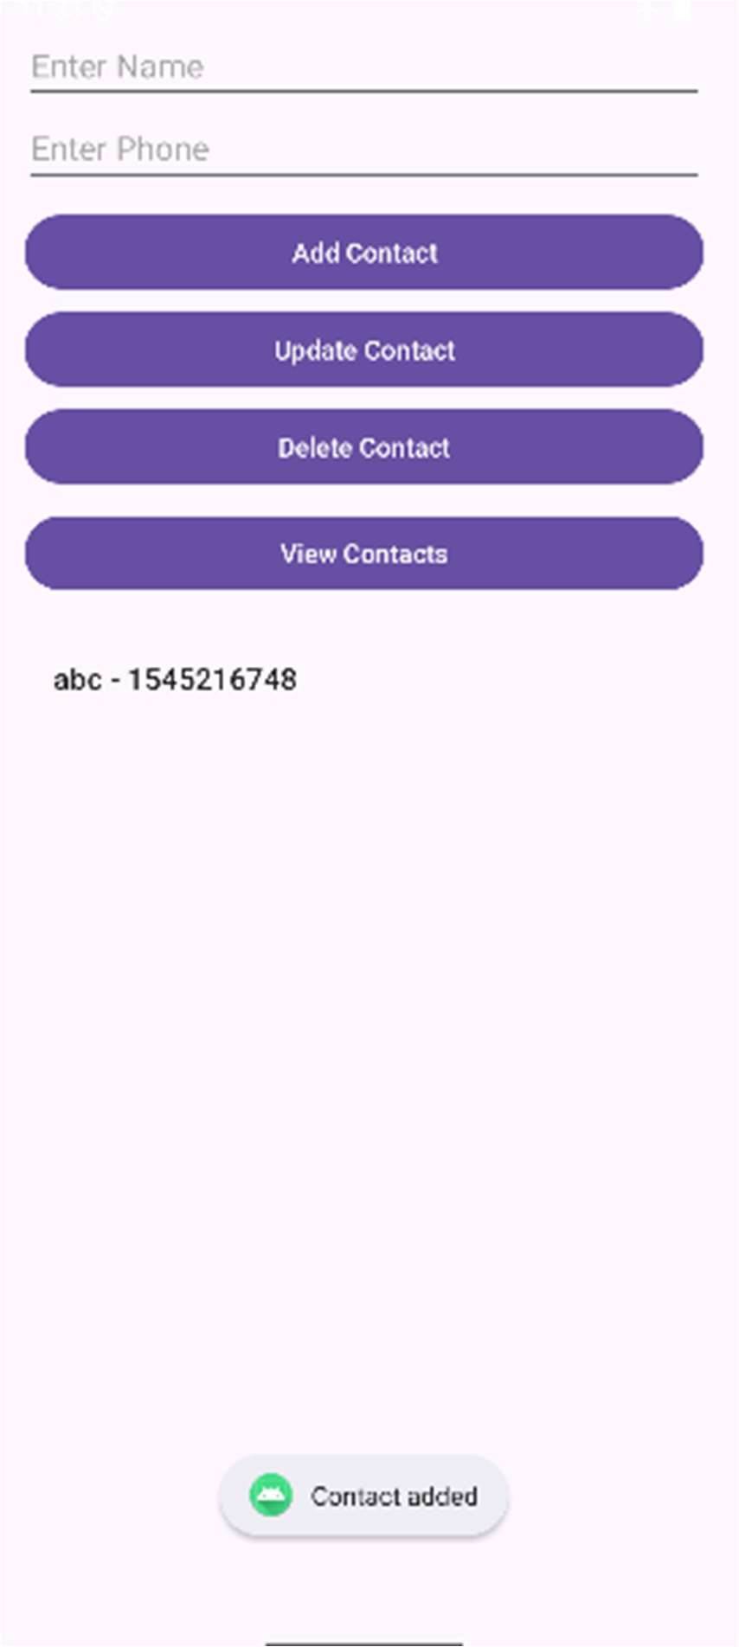

Programming Network Communications and Services (JSON)

Activity_main.xml
<?xml version="1.0" encoding="utf-8"?>
<LinearLayout xmlns:android="http://schemas.android.com/apk/res/android" android:layout_width="match_parent" android:layout_height="match_parent"
android:orientation="vertical" android:padding="20dp">
<Button
android:id="@+id/btnFetch" android:layout_width="match_parent" android:layout_height="wrap_content" android:text="Fetch Data" />
<ListView android:id="@+id/lvData"
android:layout_width="match_parent" android:layout_height="wrap_content" android:layout_marginTop="20dp" />
</LinearLayout>

MainActivity.java
package com.example.pract8b;

import android.os.Bundle; import android.view.View;
import android.widget.ArrayAdapter; import android.widget.Button; import android.widget.ListView; import android.widget.Toast;
import androidx.appcompat.app.AppCompatActivity; import com.android.volley.Request;
import com.android.volley.RequestQueue; import com.android.volley.Response; import com.android.volley.VolleyError;
import com.android.volley.toolbox.JsonArrayRequest; import com.android.volley.toolbox.Volley;
import org.json.JSONArray; import org.json.JSONObject; import java.util.ArrayList;

public class MainActivity extends AppCompatActivity { Button btnFetch;
ListView lvData; ArrayList<String> dataList; ArrayAdapter<String> adapter; @Override
protected void onCreate(Bundle savedInstanceState) { super.onCreate(savedInstanceState); setContentView(R.layout.activity_main);
btnFetch = findViewById(R.id.btnFetch); lvData = findViewById(R.id.lvData); dataList = new ArrayList<>();
adapter = new ArrayAdapter<>(this, android.R.layout.simple_list_item_1, dataList); lvData.setAdapter(adapter);

btnFetch.setOnClickListener(new View.OnClickListener() { @Override
public void onClick(View v) { fetchJSONData();
}
});
}
private void fetchJSONData() {
String url = "https://jsonplaceholder.typicode.com/users"; // Sample JSON API RequestQueue requestQueue = Volley.newRequestQueue(this); JsonArrayRequest jsonArrayRequest = new JsonArrayRequest(
Request.Method.GET, url,
null,
new Response.Listener<JSONArray>() { @Override
public void onResponse(JSONArray response) { dataList.clear();
try {
for (int i = 0; i < response.length(); i++) { JSONObject obj = response.getJSONObject(i); String name = obj.getString("name");
String email = obj.getString("email");
String city = obj.getJSONObject("address").getString("city"); dataList.add(name + " - " + email + " - " + city);
}
adapter.notifyDataSetChanged();
} catch (Exception e) { e.printStackTrace();
Toast.makeText(MainActivity.this, "Parsing error", Toast.LENGTH_SHORT).show();
}
}
},
new Response.ErrorListener() { @Override
public void onErrorResponse(VolleyError error) {
Toast.makeText(MainActivity.this, "Network error", Toast.LENGTH_SHORT).show();
}
}
);
requestQueue.add(jsonArrayRequest);
}
}

build.gradle.kts (module app)
Add this inside dependencies in build.gradle.kts(app) in Gradle scripts implementation("com.android.volley:volley:1.2.1")

dependencies {
implementation("com.android.volley:volley:1.2.1")
}

AndriodManifest.xml
Add this above application tag

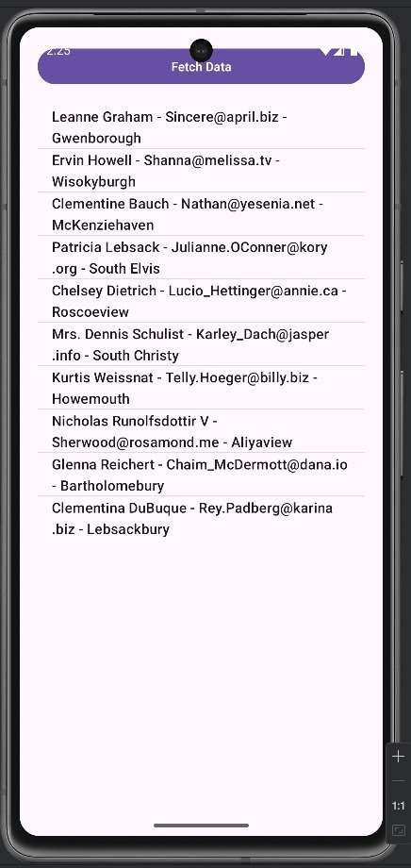
<uses-permission android:name="android.permission.INTERNET" /> Output:

Practical 9 Programming threads, handles and asynchronized programs Activity_main.xml
<?xml version="1.0" encoding="utf-8"?>
<LinearLayout xmlns:android="http://schemas.android.com/apk/res/android" android:layout_width="match_parent" android:layout_height="match_parent"
android:orientation="vertical" android:padding="20dp">
<Button
android:id="@+id/btnStartThread" android:layout_width="match_parent" android:layout_height="wrap_content" android:text="Start Thread" />
<TextView android:id="@+id/tvThreadStatus" android:layout_width="match_parent" android:layout_height="wrap_content" android:text="Thread not started" android:textSize="18sp" android:layout_marginTop="20dp"/>
</LinearLayout>

MainActivity.java
package com.example.pract9a;

import android.os.Bundle; import android.view.View; import android.widget.Button; import android.widget.TextView;
import androidx.appcompat.app.AppCompatActivity;

public class MainActivity extends AppCompatActivity { Button btnStartThread;
TextView tvThreadStatus; @Override
protected void onCreate(Bundle savedInstanceState) { super.onCreate(savedInstanceState); setContentView(R.layout.activity_main); btnStartThread = findViewById(R.id.btnStartThread); tvThreadStatus = findViewById(R.id.tvThreadStatus);
btnStartThread.setOnClickListener(new View.OnClickListener() { @Override
public void onClick(View v) {
// Create a new thread
Thread thread = new Thread(new Runnable() { @Override
public void run() {
// This is running in background thread
for (int i = 1; i <= 5; i++) { final int count = i;
// Update UI safely
runOnUiThread(new Runnable() { @Override
public void run() { tvThreadStatus.setText("Count: " + count);

}
});
try {
Thread.sleep(1000); // Sleep 1 second
} catch (InterruptedException e) { e.printStackTrace();
}
}
// Final message
runOnUiThread(new Runnable() { @Override
public void run() { tvThreadStatus.setText("Thread finished!");

}
});
}
});

}
});
}
}
thread.start();

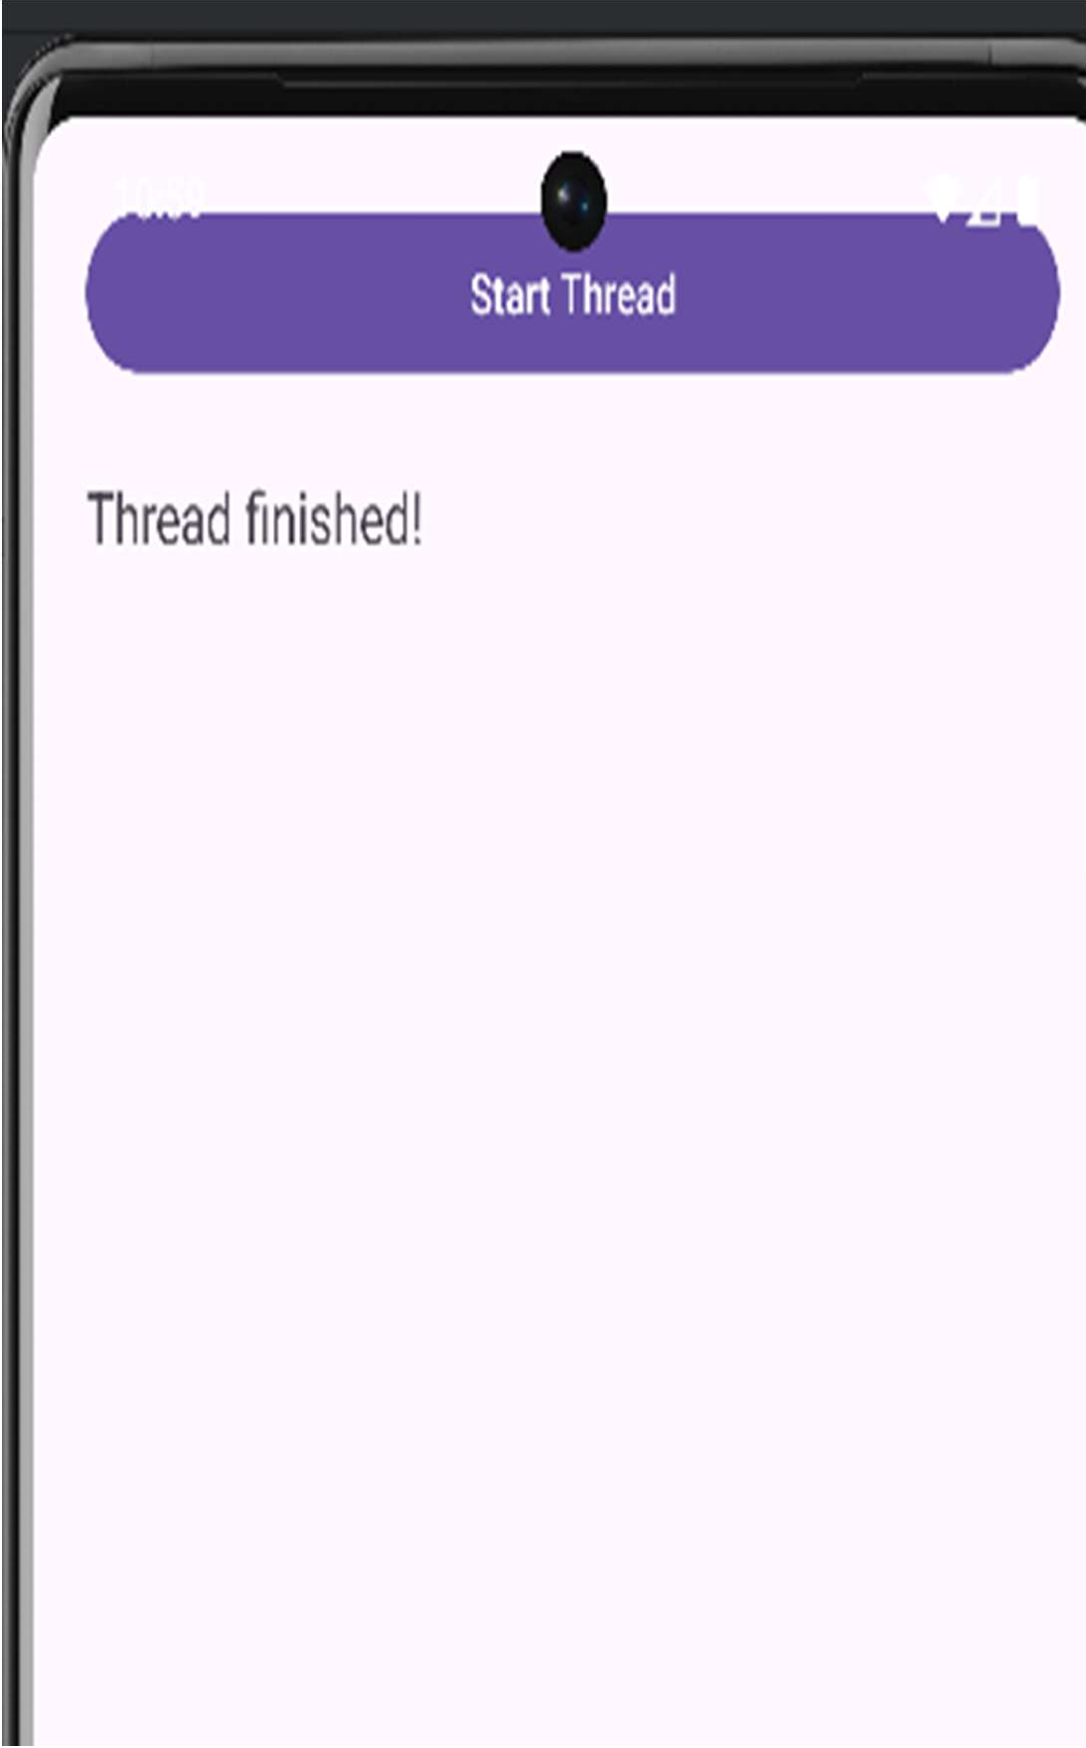
Output:
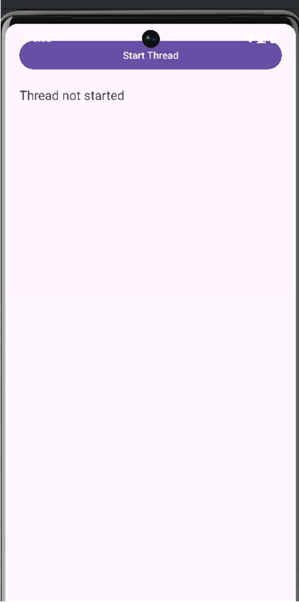

Activity_main.xml
<?xml version="1.0" encoding="utf-8"?>
<LinearLayout xmlns:android="http://schemas.android.com/apk/res/android" android:layout_width="match_parent" android:layout_height="match_parent"
android:orientation="vertical" android:padding="20dp">

<Button
android:id="@+id/btnStartStop" android:layout_width="match_parent" android:layout_height="wrap_content" android:text="Start Timer" />

<TextView android:id="@+id/tvTimer"
android:layout_width="match_parent" android:layout_height="wrap_content" android:text="Time: 0" android:textSize="18sp" android:layout_marginTop="20dp" />
</LinearLayout>

MainActivity.java
package com.example.pract9b;

import android.os.Bundle; import android.os.Handler; import android.view.View; import android.widget.Button; import android.widget.TextView;

import androidx.appcompat.app.AppCompatActivity; public class MainActivity extends AppCompatActivity {
Button btnStartStop; TextView tvTimer; int counter = 0;
boolean isRunning = false; Handler handler = new Handler();
// Runnable that updates the UI every second
Runnable runnable = new Runnable() { @Override
public void run() { counter++;
tvTimer.setText("Time: " + counter);

// Repeat every 1 second
handler.postDelayed(this, 1000);
}
};

@Override

protected void onCreate(Bundle savedInstanceState) { super.onCreate(savedInstanceState); setContentView(R.layout.activity_main);

btnStartStop = findViewById(R.id.btnStartStop); tvTimer = findViewById(R.id.tvTimer);

btnStartStop.setOnClickListener(new View.OnClickListener() { @Override
public void onClick(View v) {

if (!isRunning) {
handler.post(runnable); // Start the timer btnStartStop.setText("Stop Timer"); isRunning = true;
} else {
handler.removeCallbacks(runnable); // Stop the timer
btnStartStop.setText("Start Timer"); isRunning = false;
}
}
});
}
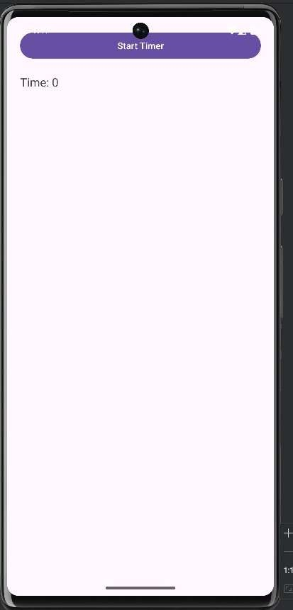
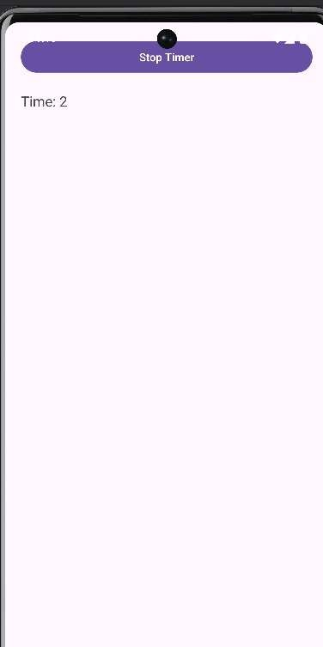
output:

Practical 10 A] Programming Media API and Telephone API
  - Create a folder ‘raw’ under res
  - Download an mp3 file and name the file as sample_audio.mp3
  - Drag and drop it in the raw folder.

Activity_main.xml
<?xml version="1.0" encoding="utf-8"?>
<LinearLayout xmlns:android="http://schemas.android.com/apk/res/android" android:orientation="vertical"
android:gravity="center" android:padding="20dp" android:layout_width="match_parent" android:layout_height="match_parent">

<Button
android:id="@+id/btnPlay" android:text="Play" android:layout_width="wrap_content" android:layout_height="wrap_content" />

<Button
android:id="@+id/btnPause" android:text="Pause" android:layout_marginTop="20dp" android:layout_width="wrap_content" android:layout_height="wrap_content" />

</LinearLayout>

MainActivity.java
package com.example.pract10a;

package com.example.pract9a;

import android.media.MediaPlayer; import android.os.Bundle;
import android.widget.Button;
import androidx.appcompat.app.AppCompatActivity; public class MainActivity extends AppCompatActivity {
private MediaPlayer mediaPlayer; private Button btnPlay, btnPause;

@Override
protected void onCreate(Bundle savedInstanceState) { super.onCreate(savedInstanceState); setContentView(R.layout.activity_main);

btnPlay = findViewById(R.id.btnPlay); btnPause = findViewById(R.id.btnPause);

// Initialize MediaPlayer with the audio file from res/raw
mediaPlayer = MediaPlayer.create(this, R.raw.sample_audio);

btnPlay.setOnClickListener(v -> { if (!mediaPlayer.isPlaying()) {
mediaPlayer.start();
}
});

btnPause.setOnClickListener(v -> { if (mediaPlayer.isPlaying()) {
mediaPlayer.pause();
}
});
}

@Override
protected void onDestroy() { super.onDestroy();
if (mediaPlayer != null) { mediaPlayer.release(); mediaPlayer = null;
}
}
}

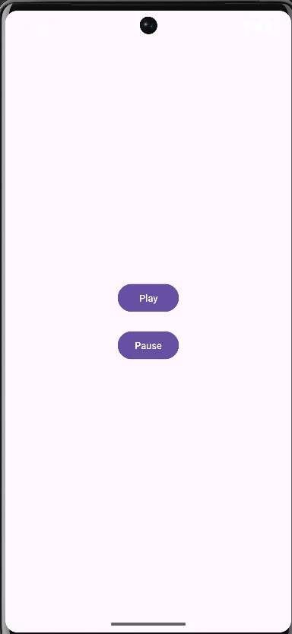
output:

Telephone API Activity_main.xml
<?xml version="1.0" encoding="utf-8"?>
<LinearLayout xmlns:android="http://schemas.android.com/apk/res/android" android:orientation="vertical"
android:gravity="center" android:padding="20dp" android:layout_width="match_parent" android:layout_height="match_parent">

<EditText android:id="@+id/edtNumber" android:hint="Enter phone number" android:inputType="phone" android:layout_width="match_parent"
android:layout_height="wrap_content"/>

<Button
android:id="@+id/btnCall" android:text="Call" android:layout_marginTop="20dp" android:layout_width="wrap_content" android:layout_height="wrap_content"/>
</LinearLayout>

MainActivity.java
package com.example.pract10b;

import android.Manifest; import android.content.Intent;
import android.content.pm.PackageManager; import android.net.Uri;
import android.os.Bundle; import android.widget.Button; import android.widget.EditText; import android.widget.Toast;
import androidx.appcompat.app.AppCompatActivity; import androidx.core.app.ActivityCompat;
import androidx.core.content.ContextCompat;

public class MainActivity extends AppCompatActivity { private static final int REQUEST_CALL = 1;
EditText edtNumber; Button btnCall;

@Override
protected void onCreate(Bundle savedInstanceState) { super.onCreate(savedInstanceState); setContentView(R.layout.activity_main);

edtNumber = findViewById(R.id.edtNumber); btnCall = findViewById(R.id.btnCall);

btnCall.setOnClickListener(v -> makeCall());
}

private void makeCall() {
String number = edtNumber.getText().toString().trim(); if (number.isEmpty()) {
Toast.makeText(this, "Enter a phone number", Toast.LENGTH_SHORT).show(); return;
}

if (ContextCompat.checkSelfPermission(this, Manifest.permission.CALL_PHONE)
!= PackageManager.PERMISSION_GRANTED) { ActivityCompat.requestPermissions(this,
new String[]{Manifest.permission.CALL_PHONE}, REQUEST_CALL);
} else {
startCall(number);
}
}

private void startCall(String number) {
Intent callIntent = new Intent(Intent.ACTION_CALL); callIntent.setData(Uri.parse("tel:" + number)); startActivity(callIntent);
}

@Override
public void onRequestPermissionsResult(int requestCode, String[] permissions, int[] grantResults) { if (requestCode == REQUEST_CALL) {
if (grantResults.length > 0 && grantResults[0] == PackageManager.PERMISSION_GRANTED) { makeCall();
} else {
Toast.makeText(this, "Permission denied to make calls", Toast.LENGTH_SHORT).show();
}
}
super.onRequestPermissionsResult(requestCode, permissions, grantResults);
}
}

Androidmanifest.xml
<?xml version="1.0" encoding="utf-8"?>
<manifest xmlns:android="http://schemas.android.com/apk/res/android" xmlns:tools="http://schemas.android.com/tools">
<uses-feature android:name="android.hardware.telephony" android:required="false" />
<uses-permission android:name="android.permission.CALL_PHONE"/>
<application android:allowBackup="true"
android:dataExtractionRules="@xml/data_extraction_rules" android:fullBackupContent="@xml/backup_rules" android:icon="@mipmap/ic_launcher" android:label="@string/app_name" android:roundIcon="@mipmap/ic_launcher_round" android:supportsRtl="true" android:theme="@style/Theme.Pract10b">
<activity android:name=".MainActivity" android:exported="true">
<intent-filter>
<action android:name="android.intent.action.MAIN" />
<category android:name="android.intent.category.LAUNCHER" />
</intent-filter>
</activity>
</application>
</manifest>

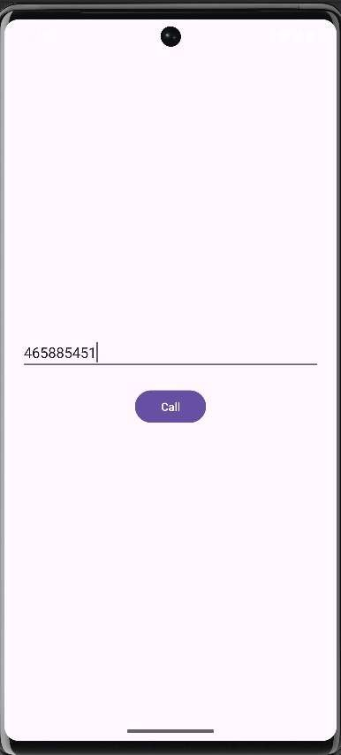
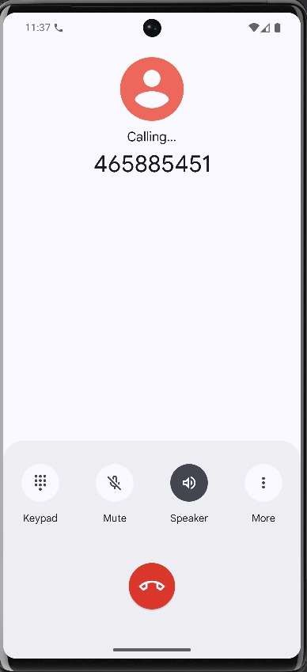
Output:

b. Programming Security and permissions Androidmanifest.xml
<uses-feature android:name="android.hardware.telephony" android:required="false" />
<uses-feature android:name="android.hardware.camera" android:required="false" />
<uses-permission android:name="android.permission.RECEIVE_SMS"/>
<uses-permission android:name="android.permission.ACCESS_FINE_LOCATION" tools:ignore="CoarseFineLocation" />

Activity_main.xml
<?xml version="1.0" encoding="utf-8"?>
<LinearLayout xmlns:android="http://schemas.android.com/apk/res/android" android:orientation="vertical"
android:gravity="center" android:padding="20dp" android:layout_width="match_parent" android:layout_height="match_parent">
<Button
android:id="@+id/btnCamera" android:text="Use Camera" android:layout_width="wrap_content" android:layout_height="wrap_content"/>
<Button
android:id="@+id/btnLocation" android:text="Access Location" android:layout_marginTop="20dp" android:layout_width="wrap_content" android:layout_height="wrap_content"/>
<Button
android:id="@+id/btnSms" android:text="Receive SMS" android:layout_marginTop="20dp" android:layout_width="wrap_content" android:layout_height="wrap_content"/>
</LinearLayout>

MainActivity.java
package com.example.pract10c;

import android.Manifest; import android.content.Intent;
import android.content.pm.PackageManager; import android.location.Location;
import android.net.Uri; import android.os.Bundle;
import android.provider.MediaStore; import android.widget.Button; import android.widget.Toast;
import androidx.appcompat.app.AppCompatActivity; import androidx.core.app.ActivityCompat;
import androidx.core.content.ContextCompat;

public class MainActivity extends AppCompatActivity {
private static final int CAMERA_PERMISSION_CODE = 101; private static final int LOCATION_PERMISSION_CODE = 102; private static final int SMS_PERMISSION_CODE = 103; private static final int CAMERA_INTENT_CODE = 201;
Button btnCamera, btnLocation, btnSms; @Override
protected void onCreate(Bundle savedInstanceState) { super.onCreate(savedInstanceState); setContentView(R.layout.activity_main); btnCamera = findViewById(R.id.btnCamera); btnLocation = findViewById(R.id.btnLocation); btnSms = findViewById(R.id.btnSms);
btnCamera.setOnClickListener(v -> checkCameraPermission()); btnLocation.setOnClickListener(v -> checkLocationPermission()); btnSms.setOnClickListener(v -> checkSmsPermission());
}
// ================= CAMERA =================
private void checkCameraPermission() {
if (ContextCompat.checkSelfPermission(this, Manifest.permission.CAMERA)
== PackageManager.PERMISSION_GRANTED) { openCamera();
} else {
ActivityCompat.requestPermissions(this,
new String[]{Manifest.permission.CAMERA},
CAMERA_PERMISSION_CODE);
}
}
private void openCamera() {
Intent cameraIntent = new Intent(MediaStore.ACTION_IMAGE_CAPTURE); if (cameraIntent.resolveActivity(getPackageManager()) != null) {
startActivityForResult(cameraIntent, CAMERA_INTENT_CODE);
}
}
// ================= LOCATION =================
private void checkLocationPermission() {
if (ContextCompat.checkSelfPermission(this, Manifest.permission.ACCESS_FINE_LOCATION)
== PackageManager.PERMISSION_GRANTED) { accessLocation();
} else {
ActivityCompat.requestPermissions(this,
new String[]{Manifest.permission.ACCESS_FINE_LOCATION},
LOCATION_PERMISSION_CODE);
}
}
private void accessLocation() {
// For demonstration, show mock coordinates double latitude = 12.9716; // Example: Bangalore double longitude = 77.5946;
Toast.makeText(this, "Latitude: " + latitude + "\nLongitude: " + longitude, Toast.LENGTH_LONG).show();
}
// ================= RECEIVE SMS =================
private void checkSmsPermission() {
if (ContextCompat.checkSelfPermission(this, Manifest.permission.RECEIVE_SMS)

== PackageManager.PERMISSION_GRANTED) {
Toast.makeText(this, "SMS Permission Granted ✅", Toast.LENGTH_SHORT).show();
} else {
ActivityCompat.requestPermissions(this,
new String[]{Manifest.permission.RECEIVE_SMS},
SMS_PERMISSION_CODE);
}
}
// ================= HANDLE PERMISSION RESULTS =================
@Override
public void onRequestPermissionsResult(int requestCode, String[] permissions, int[] grantResults) { if (requestCode == CAMERA_PERMISSION_CODE) {
if (grantResults.length > 0 && grantResults[0] == PackageManager.PERMISSION_GRANTED) openCamera();
else Toast.makeText(this, "Camera Permission Denied ❌", Toast.LENGTH_SHORT).show();
} else if (requestCode == LOCATION_PERMISSION_CODE) {
if (grantResults.length > 0 && grantResults[0] == PackageManager.PERMISSION_GRANTED) accessLocation();
else Toast.makeText(this, "Location Permission Denied ❌", Toast.LENGTH_SHORT).show();
} else if (requestCode == SMS_PERMISSION_CODE) {
if (grantResults.length > 0 && grantResults[0] == PackageManager.PERMISSION_GRANTED) Toast.makeText(this, "SMS Permission Granted ✅", Toast.LENGTH_SHORT).show();
else Toast.makeText(this, "SMS Permission Denied ❌", Toast.LENGTH_SHORT).show();
}
super.onRequestPermissionsResult(requestCode, permissions, grantResults);
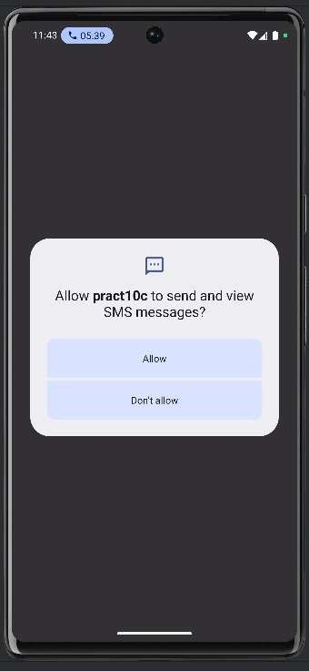
}
}

Output:

